Start a blank Stimulsoft report form
Right click on Data Sources and select “New Data Source”
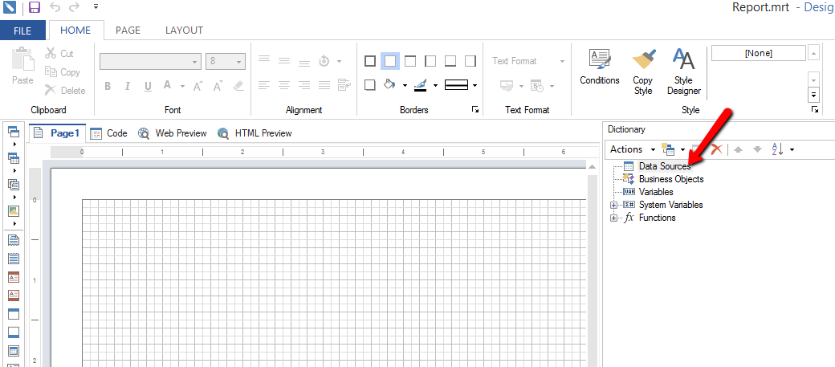
You will then want to select MS SQL from the options
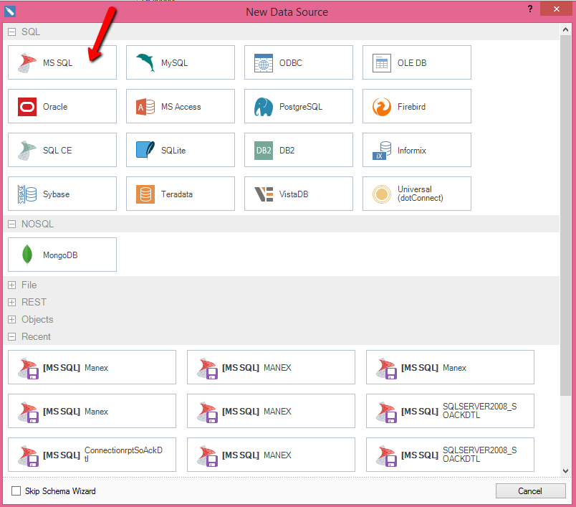

Here is the Connection String that you will want to populate with your information

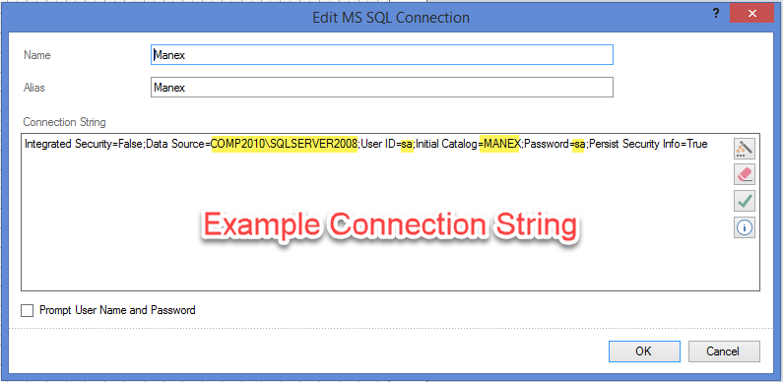
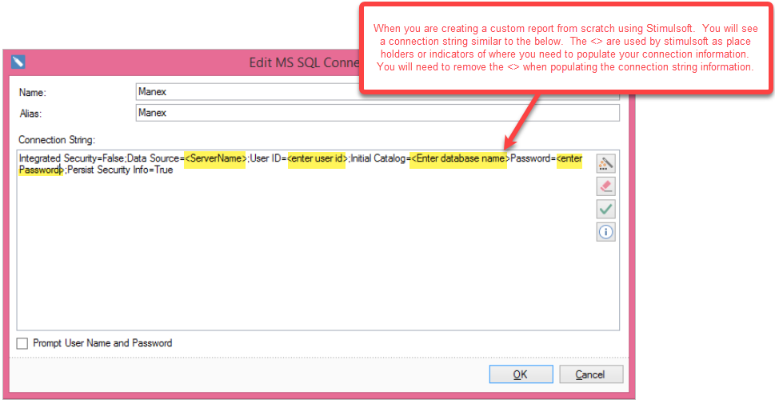

Then the following Select Data Box will display while it is retrieving the database info.
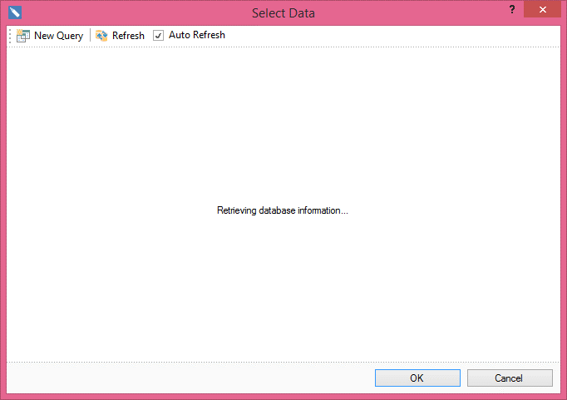

Once the database info has been retrieved you can either select from the database tables listed below or you can select New Query
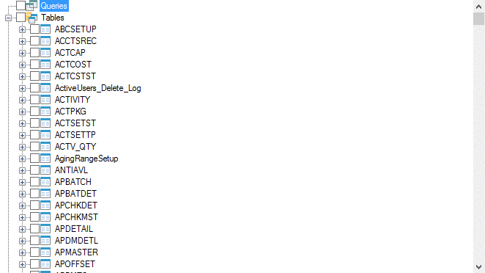
If you select New Query a screen similar to below will be displayed. You will need to enter your name Source, Name of the Query, the Query Text. Then Right click in the section shown below and select Retrieve Columns from the options. 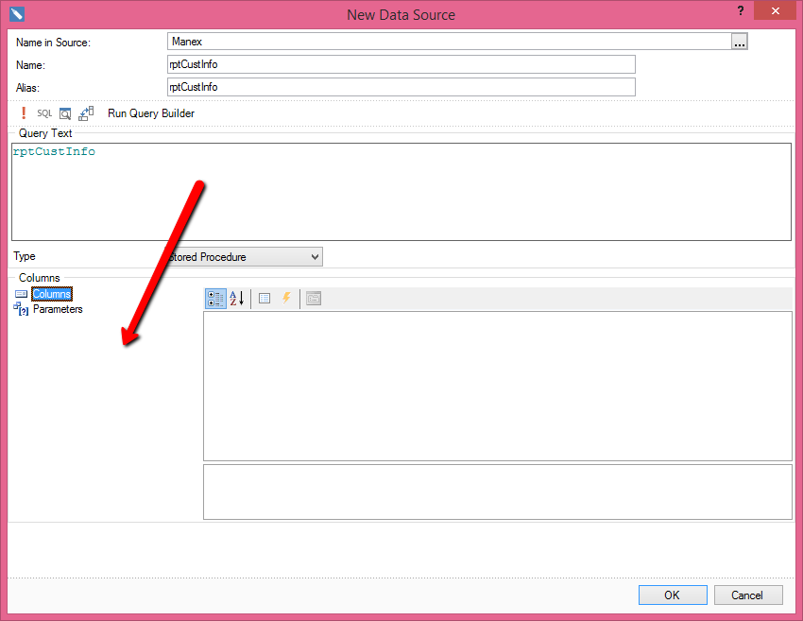

You can see the columns that were pulled from the Stored Procedure.
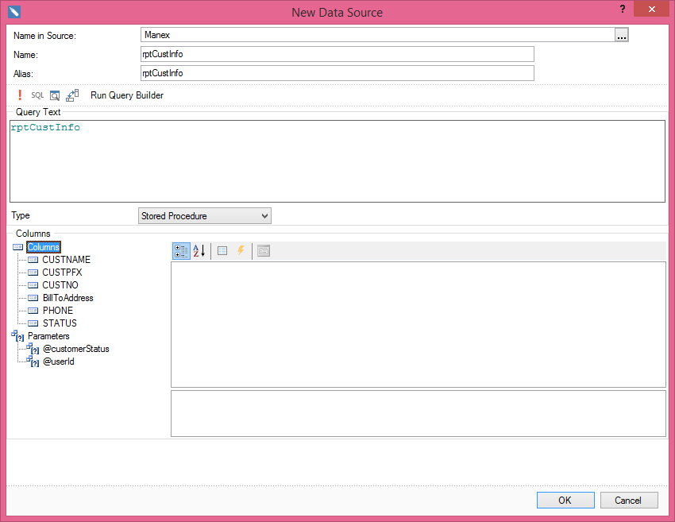
Depress the ok button in the screen above and then check mark the new Query you created to be used in the report form.
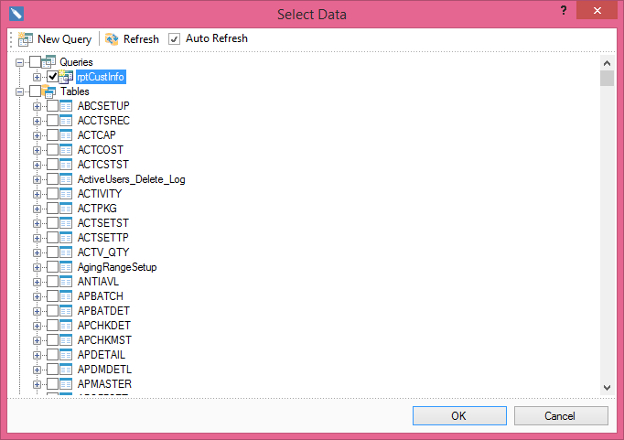
You will then see it available in the Report designer screen.
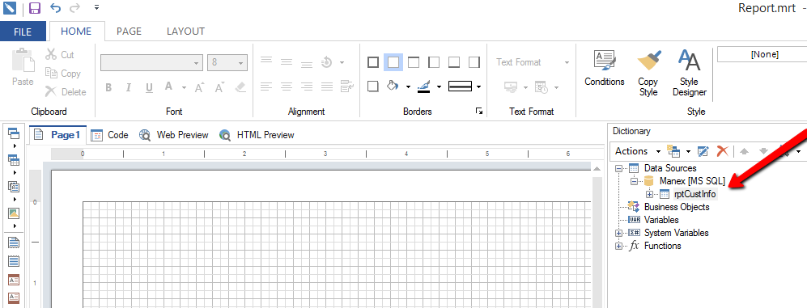
Or you can Select data from a table by entering in a select statement in the Query Text box.
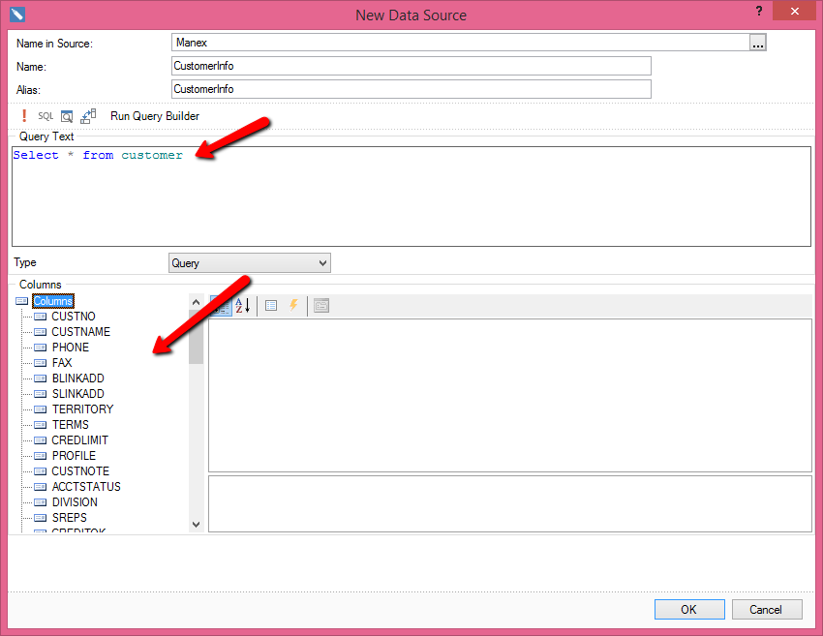
You can also create a more specific query Text if you only wanted certain fields from a table. 

