- The ABC calculation does consider leadtime. From the screen shot, you can see from the top list, most of the BUY parts have type “C” when it only considers the inventory value (standard cost x Qty OH). The bottom list shows most of parts have type “A” after considering purchase order leadtime. All the leadtime is longer than the leadtime user set up for “A” type, which is 5 days. I can see type ‘A’,’B’,’C’,’X’ all have 5 days as leadtime.
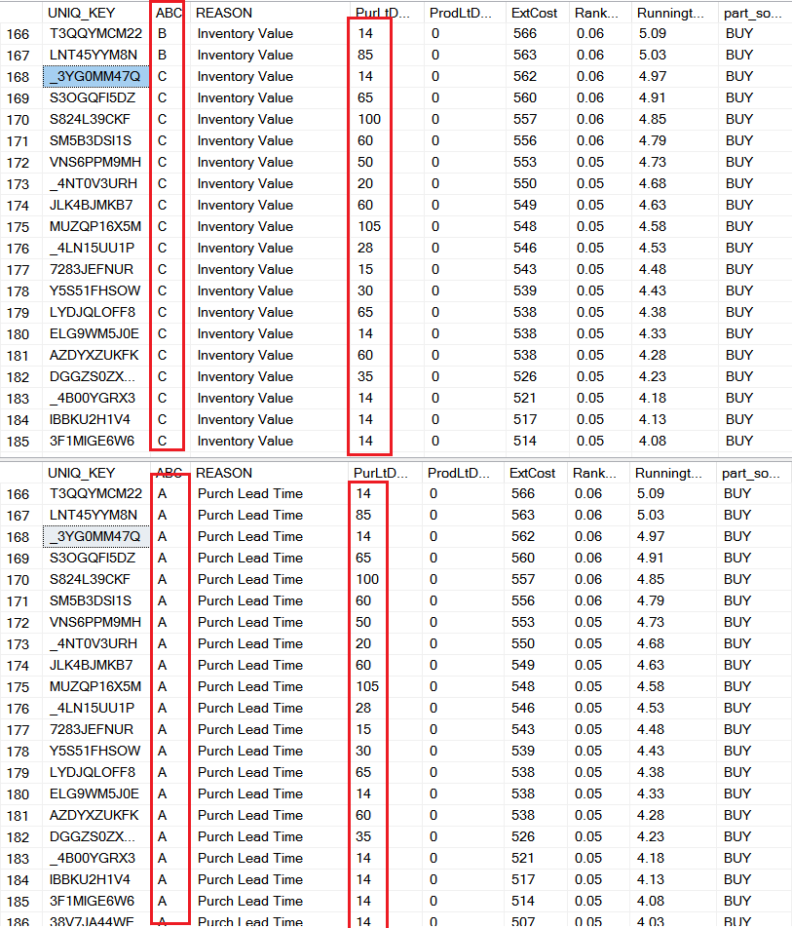

- Leadtime set up for type ‘A’
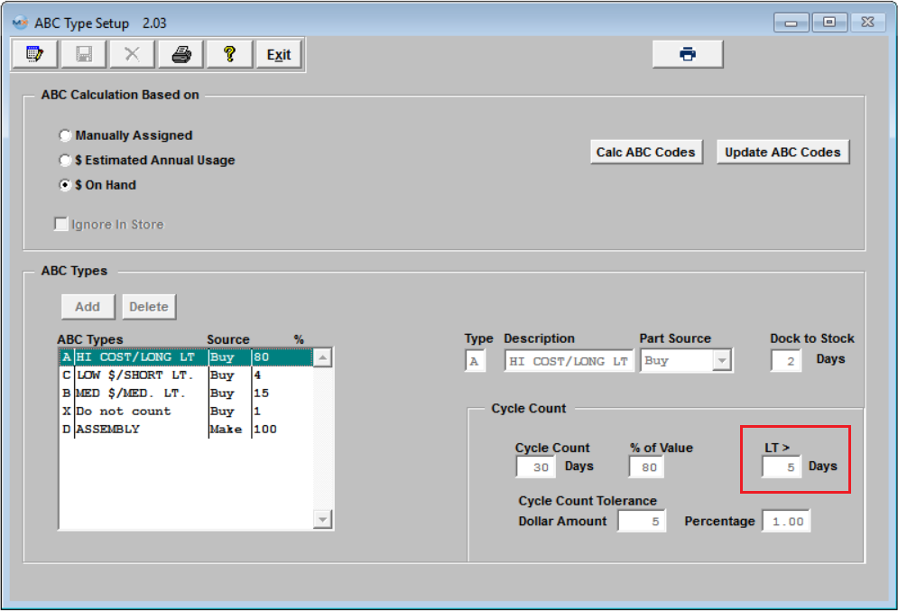
- I changed the leadtime of type ‘A’ to 100 days, type ‘B’ to 80 days, type ‘C’ to 20 days, and type ‘X’ leaves as 5 days. Then I re-calculate the ABC code. Here are the result I got
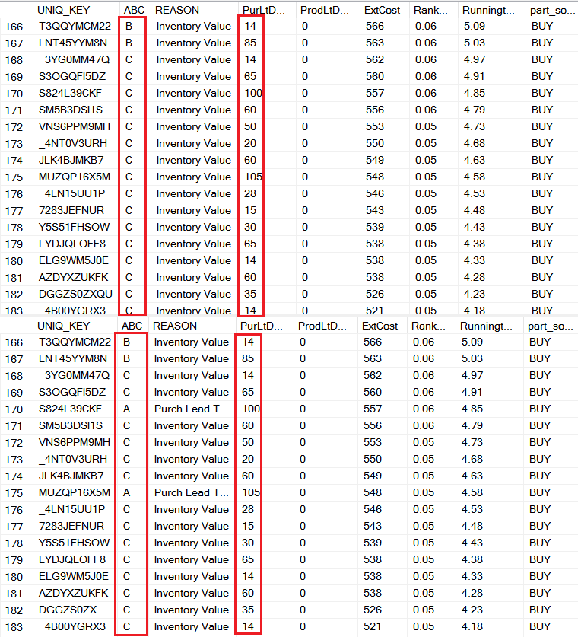
You can see the 2nd list which consider purchase leadtime only change some of them to type ‘A’. Therefore, at this point, I don’t see the ABC calculation has problems. Please see the KB http://manex.com/kb/default.asp?id=983&SID= for detail how the purchase leadtime affect the ABC type calculation.

