- The amortized amount and quantities will be calculated into invoice price until the shipped qty reaches the amort qty. For example, I have a part with amort qty 200 and amort amount $500. So the packing list/invoice for the first 200 qty need to add the amort values $500/200= $2.5 to it’s price.
- Price module
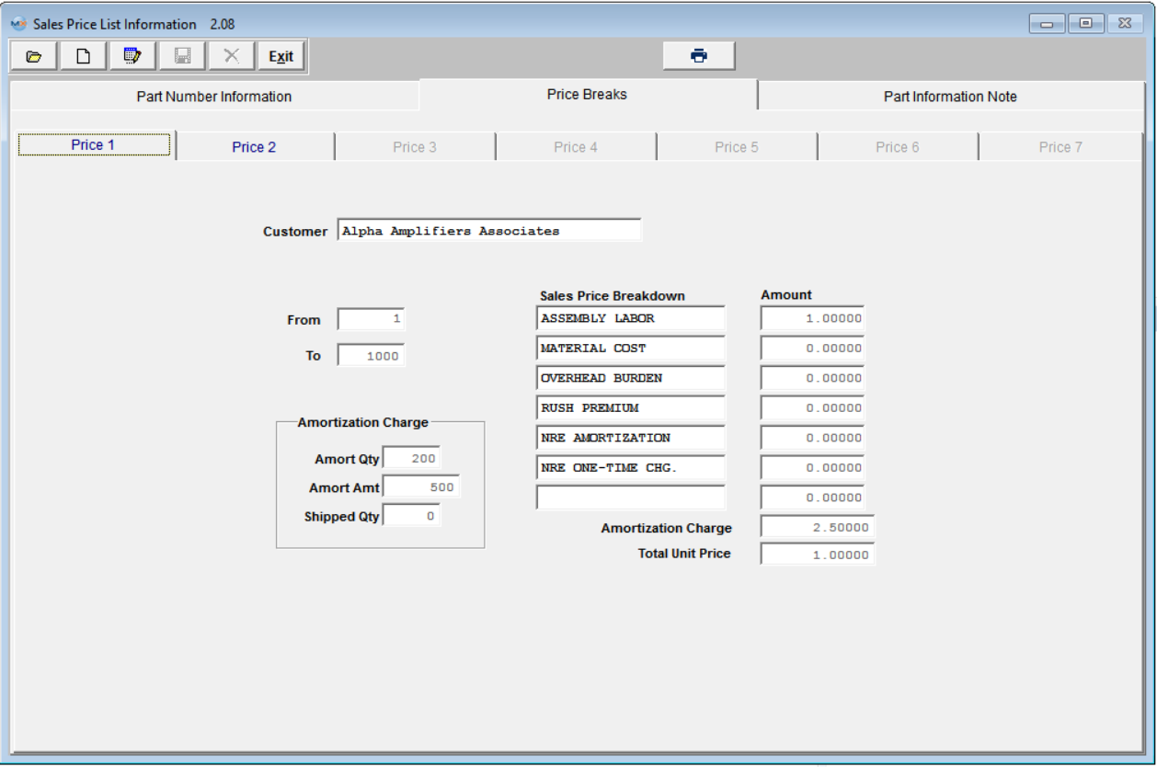
- Create a SO with order qty 600, the price is $1 (without amort charge)

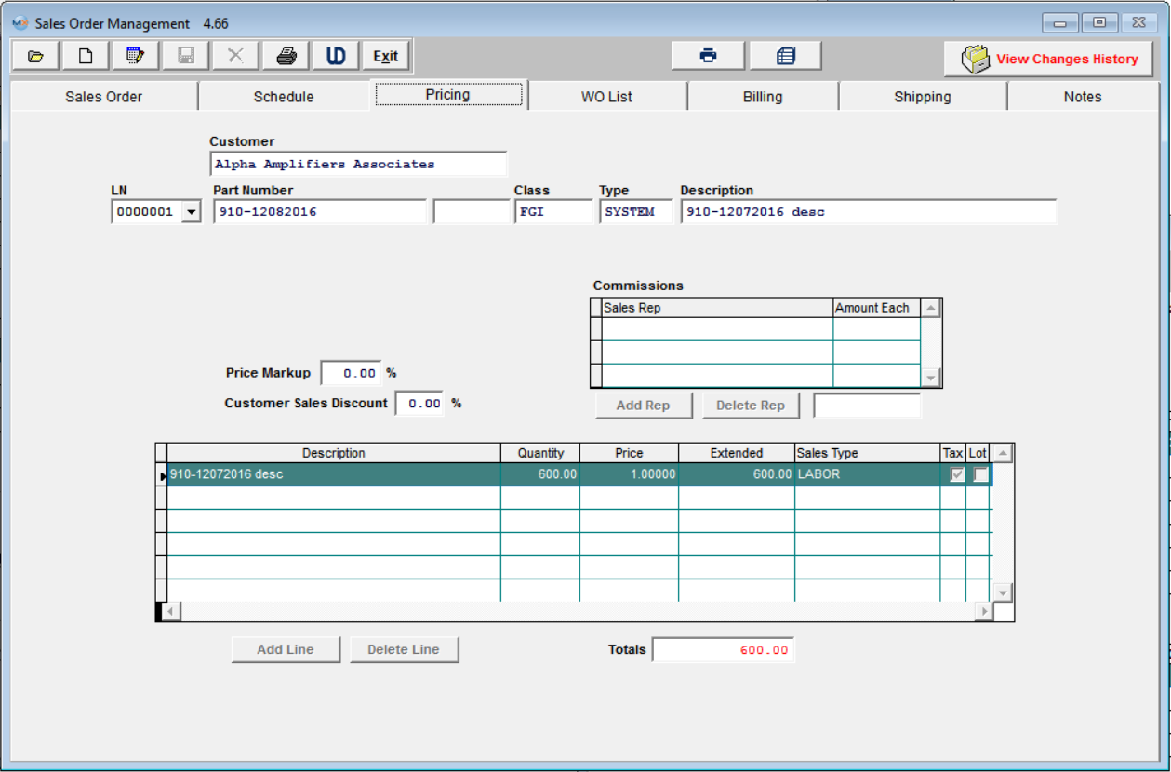

- Create 3 packing lists with qty 150, 200 and 100 for the sales order. So the first invoice will have $3.5 ($1.00 part price + $2.5 amort charge) for its price.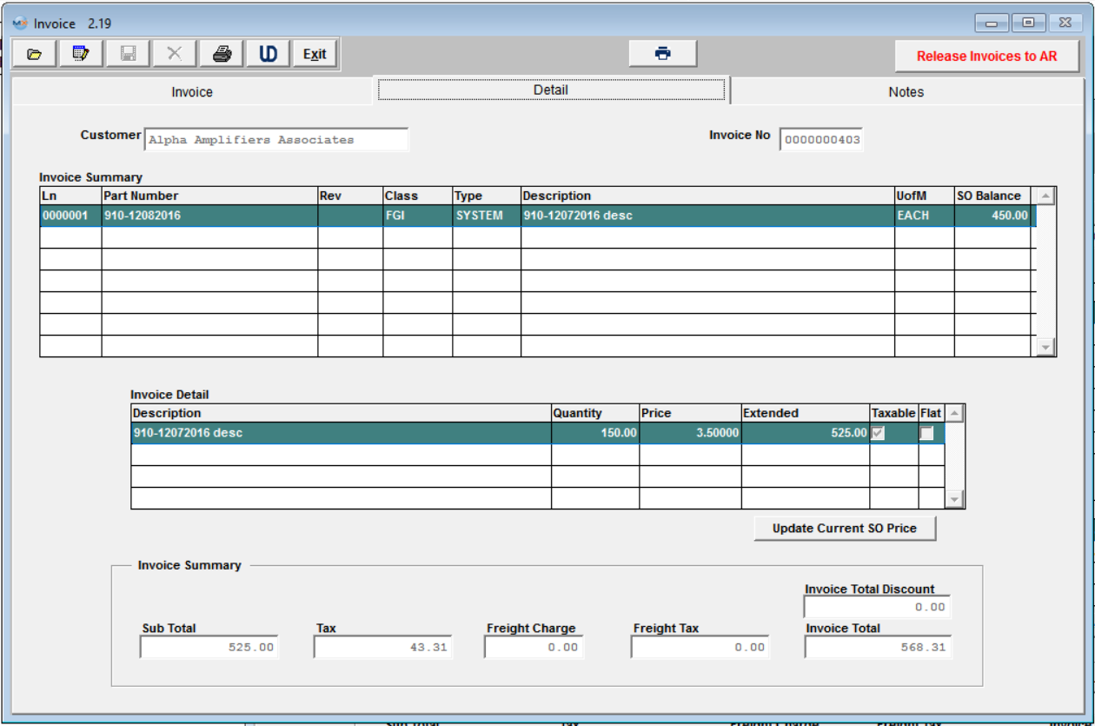
- The 2nd invoice with qty 200 will have the first qty 50 need to be added amort charge, and the rest of 150 only has part price.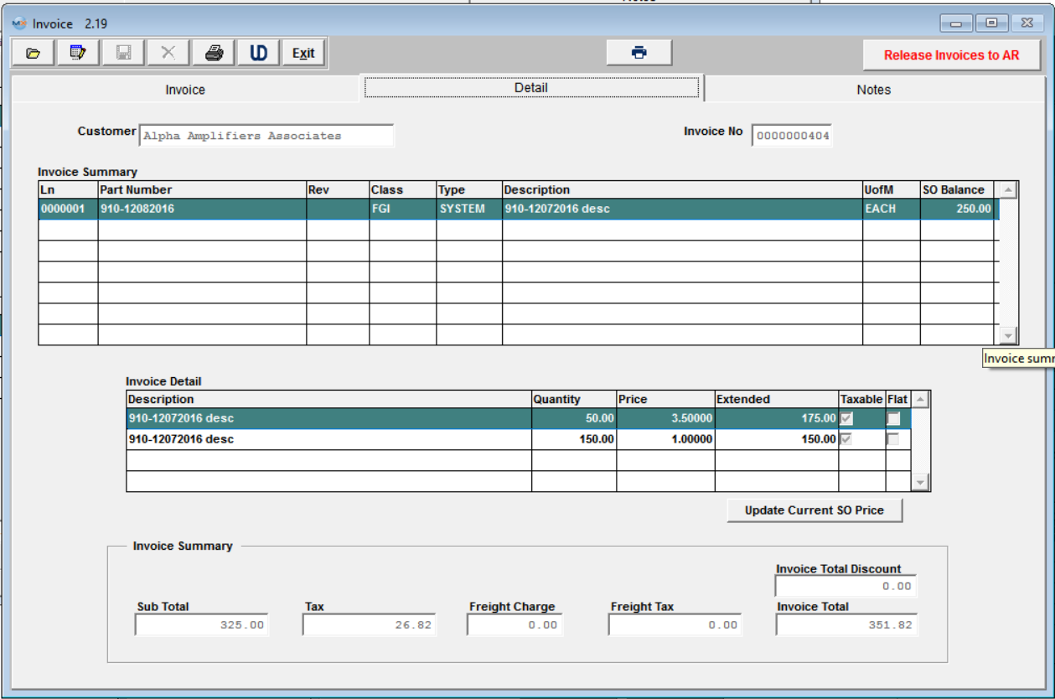
- The total 200 amort qty have been all used in previous invoices, so the last invoice doesn’t need to calculate amort charge, just use part price $1.00

