Below you can see that the Make part is carrying a Std Cost value of $13.82456 at this time.
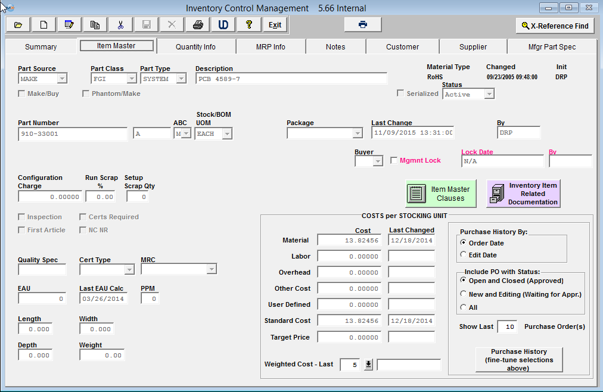
Created the Sales Order and selected “OTHER” from the Types within the Pricing tab.

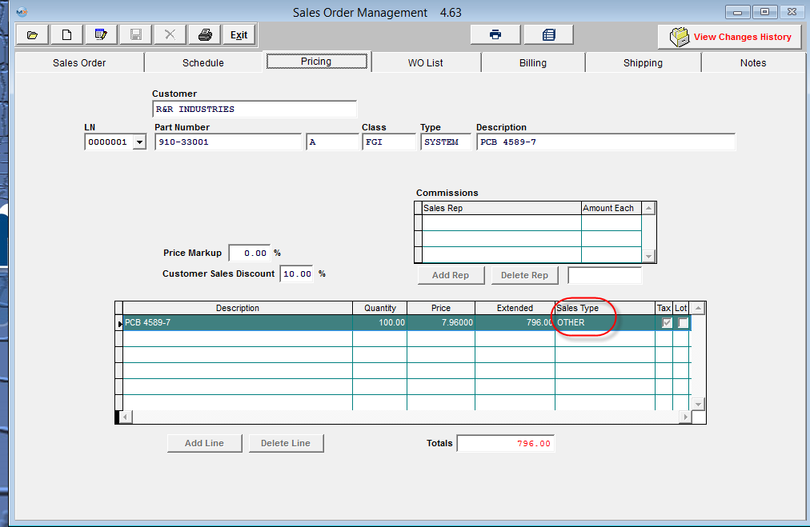

Generate a Packing list against the sales order. No transaction are generated at this time
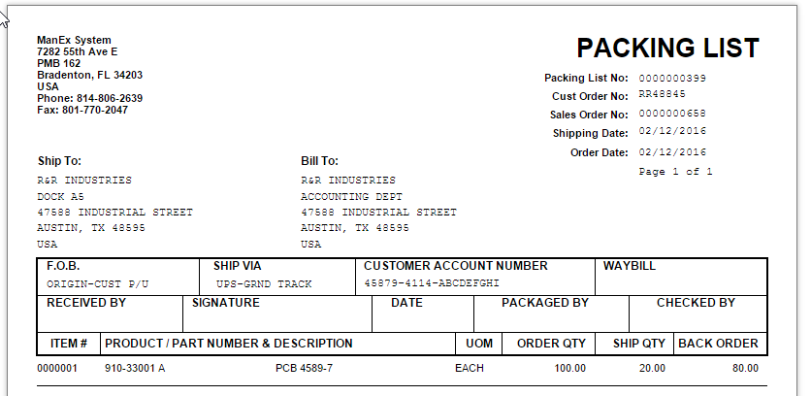
Reviewed the Invoice and then released it to AR.
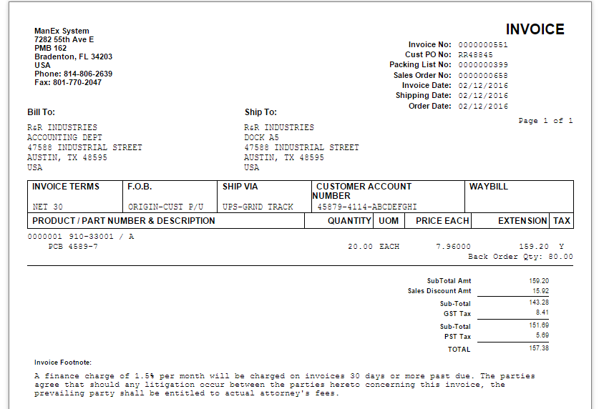

After the invoice was released to AR is when the first GL Transaction is available to be released/posted to the GL. You can see that the GL # that was assigned to the Cost GL Number field was a Debit using the Inventory Std Cost * Ship Qty. The Revenue GL # was credit Ship Qty * Price Each from Sale order.
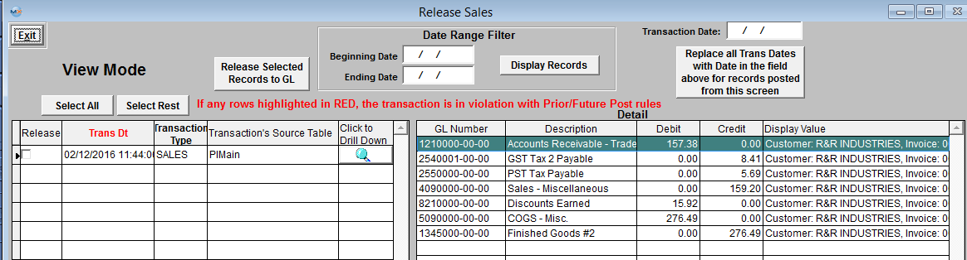
This will hopefully help you understand how the GL #’s that are populated in the Setup screen below are used when generating GL Transactions within the system.


