In this document I will demonstrate how to setup WebManex as an application under the default Web Site. The main goal is to show that Manex web application can be hosted without jeopardizing security of the web server and doesn’t require ‘sharing’ of the ‘inetpub’ or any other directories under ‘inetpub’ directory. Please notice that there are many ways to host a web application. Every company has different needs and security demands. The fine-tuning setup of the web application for each company has to be done under their network administrator (IT personal) and is beyond the scope of this document.

Step 1. Setup directories
Open ‘inetpub’ directory on your server (‘c:\inetpub’). As you can see that directory is not shared on the network, but it will allow the web application to use it.

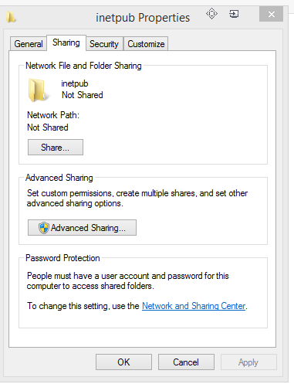
The properties for the ‘wwwroot’ directory will show ‘Not Shared’ as well

Under ‘inetpub\wwwroot’ directory create new directory. I will call it ‘WebManex’, but you can name it different. The property for the new ‘WebManex’ directory is ‘Not Shared’.
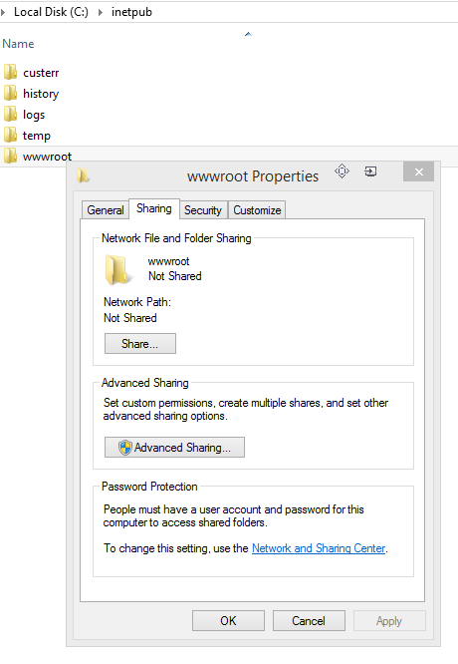

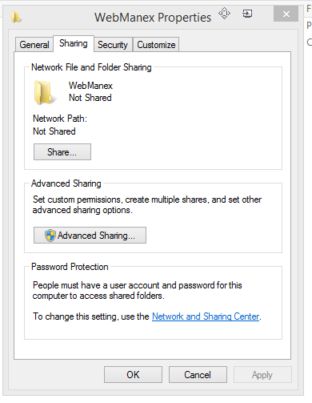

Step 2. Copy WebManex
I use temporary directory to un-zip WebManexXXXX (provided). If needed I make modifications to ‘Web.config’ in the temporary directory prior to copying it into ‘inetpub\wwwroot\webmanex’

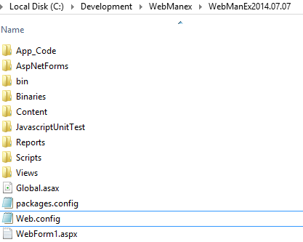
Most of the time, the only changes to the web.config needed is the connection string.
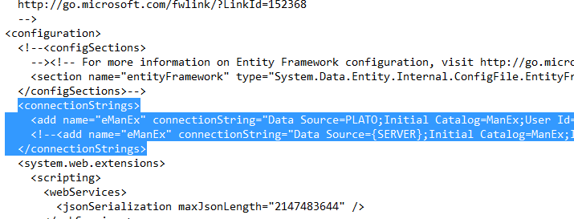
Copy all the files from your temporary location into ‘inetpub\wwwroot\webmanex’
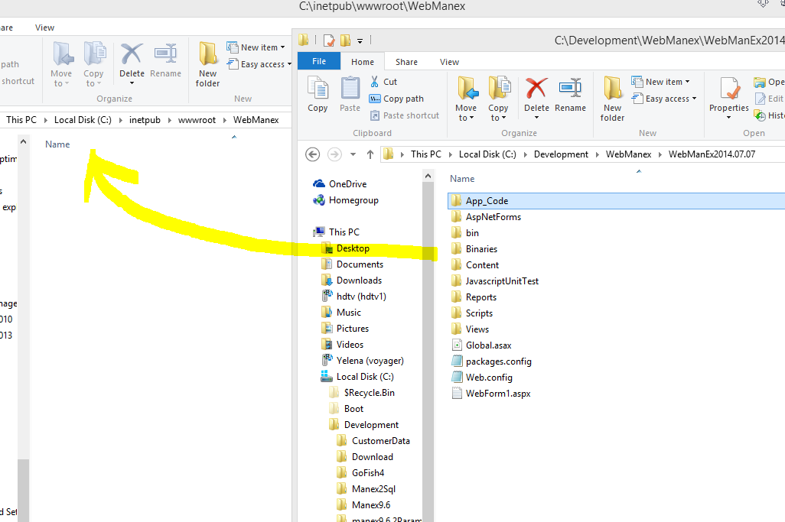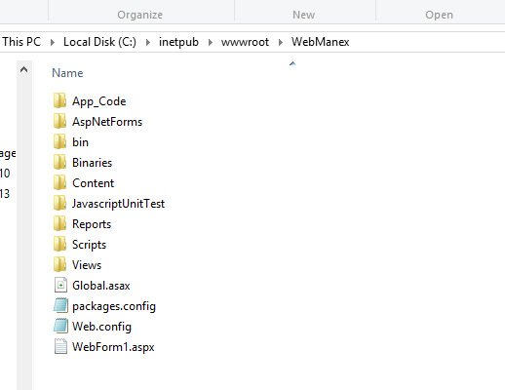

Step 3. Open IIS Manager
In this document I will setup ‘Manex’ as an application under ‘Default Web Site’

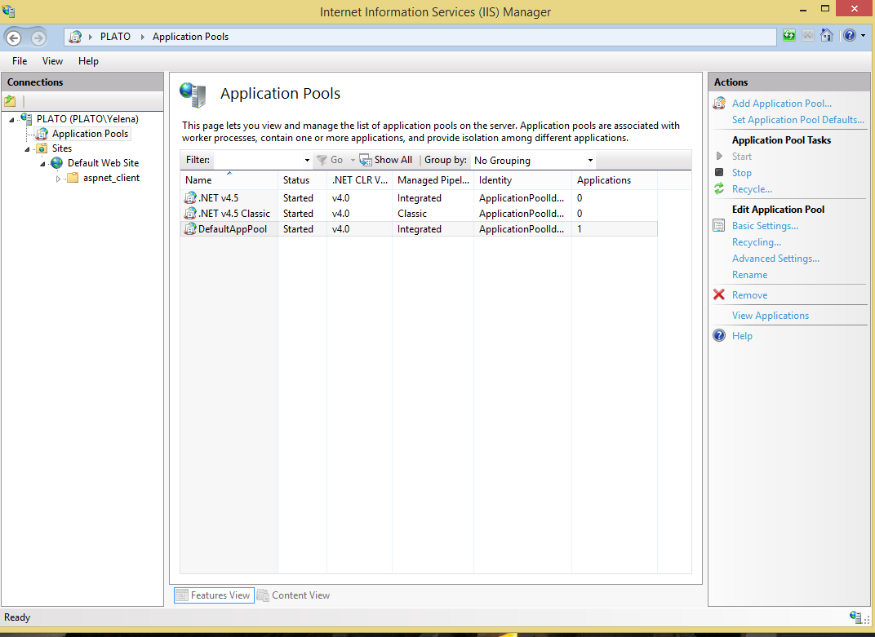
In the middle panel (Application Pools), shown above, click on the ‘DefaulAppPool’ (please notice, you can create a new application pool for your webmanex) and select ‘Advanced Setttings…’ in the right panel. Make sure that Identity set to ‘ApplicationPoolIdentity’.

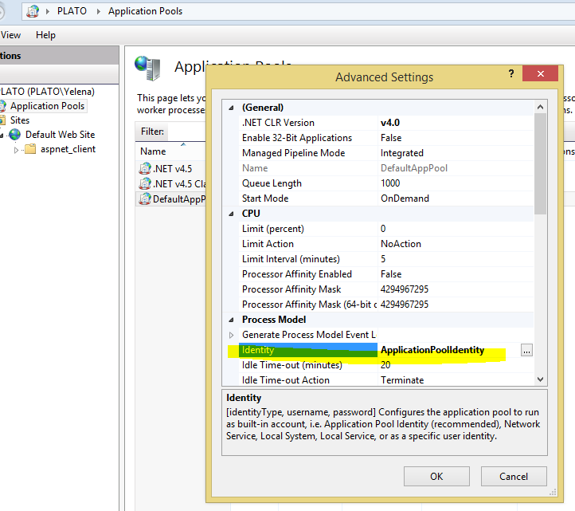
Right click on ‘Default Web Site’ and select ‘Add Application’. Enter ‘Alias’ for your application, I will enter ‘Manex’, but you can enter any name. Please notice that this is the name you will use in the browser when running webmanex, for this example we will enter localhost\manex into the browser address.
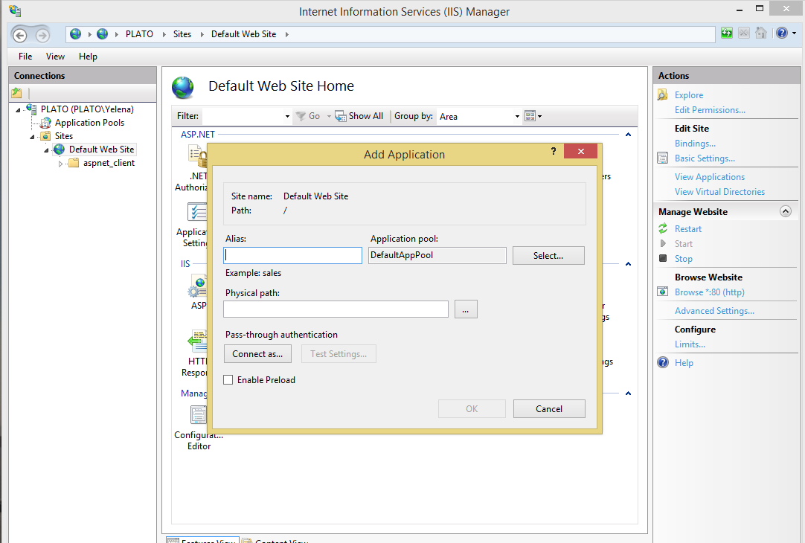
Click on “…” button next to “Physical path” to navigate to your “webmanex” directory. In this example it is going to be “c:\inetpub\wwwroot\webmanex” directory.
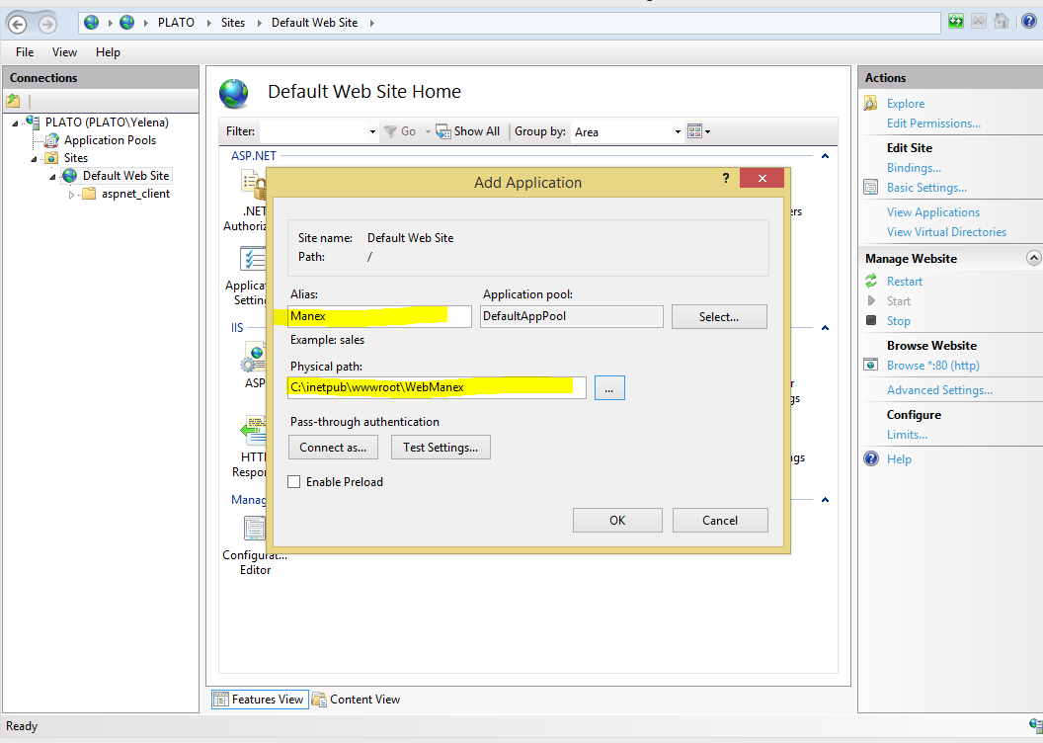
Click ‘Connect as…’ button and make sure that ‘Application user’ radio button is selected.
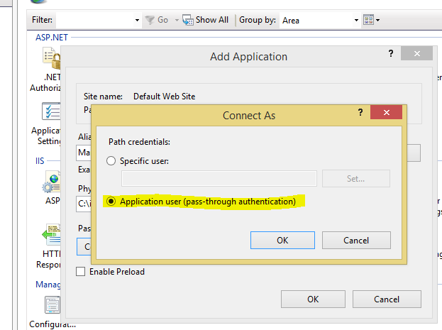

Step 4. We are almost there
You will see new ‘Manex’ under ‘Default Web Site’, right click on it and select ‘manage Application’ and then ‘Browse’. You can also click on ‘Browse..’ visible in the right panel
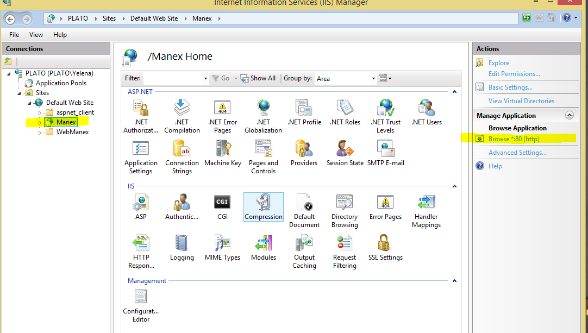
It should start your default browser with an address ‘LocalHost/Manex’ and bring you to the WebManex Login form.

Step 5. Running from a different computer on the local network
For this exercise I will run our new ‘Webmanex’ from a different computer on the network. For that I will find an IP address of my host computer and as you see above my computer is listening for the incoming connection on port 80 (default port, you can change it). I have to make sure that pre-define Rule on windows firewall for ‘World Wide Web Services (HTTP Traffic-In) is Enabled.
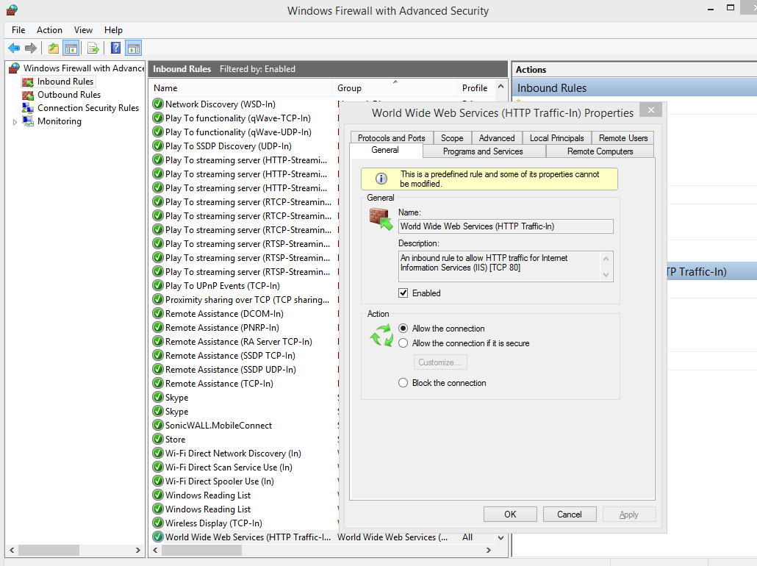
Now I am ready to run webManex from my laptop on my local network.
This computer can see my host computer (‘PLATO’), but cannot see any directories on ‘PLATO’ at this time.
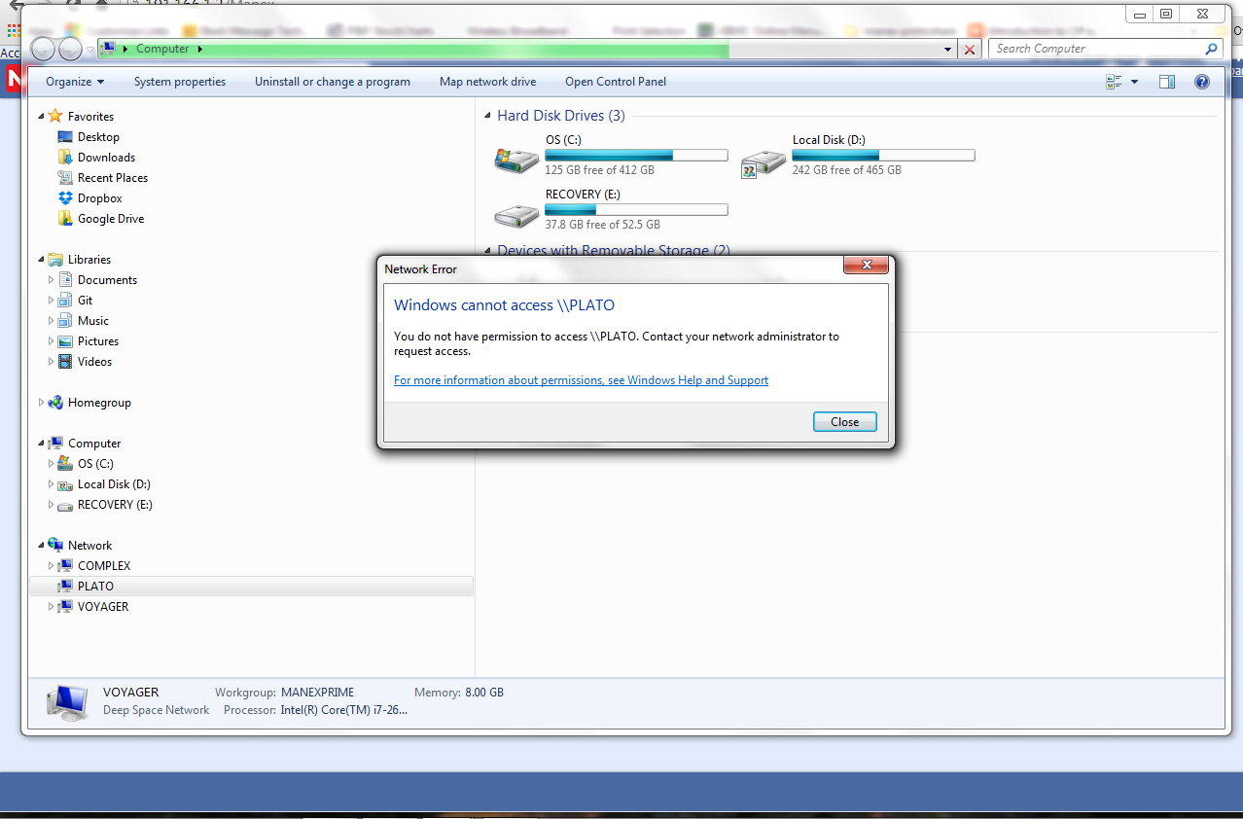
Entering, ‘PLATO’ ip address\manex in the browser address bar, I can access webmanex, and after entering my webmanex userid and password, I can use webManex


