This discussion relates to the provision in the lower right corner of the setup to establish tolerances for cycle count reporting.

When cycle counting is performed, in certain categories of parts, it may not be practical to be concerned about a few missing parts. For example, a few parts missing from reeled passive parts may not be worth bothering about. So the user may establish tolerances on when to be concerned. If a cycle count of 4800 parts ends up being 50 parts short, is that a serious issue? If so, the tolerance would be set at 1%, above which calls to the users attention that there might be a problem with the item. But if the item only costs fractions of a penny each, then it would probably cost more to track down why it is off than to forget about the loss. On the other hand, if the reel (or pack or tube or tray, etc.) contained many parts, but the parts were expensive, then it would be prudent to put a maximum dollar amount on the tolerance, so that if more than that value is missing (or overage) it would be prudent to examine what happened with such an item.

This ties into the ABC code in the sense that A parts, which are typically the most expensive parts, may have cycle counting maximum error rate very low, such as 1%, and a dollar tolerance of $50.

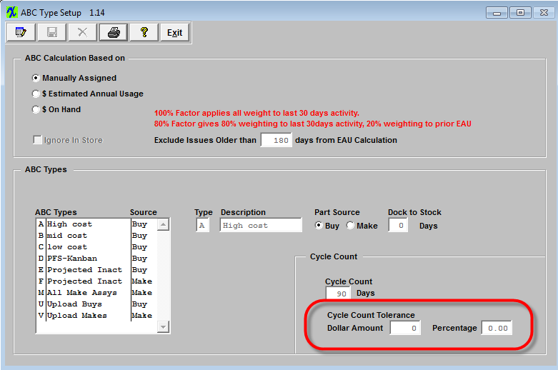

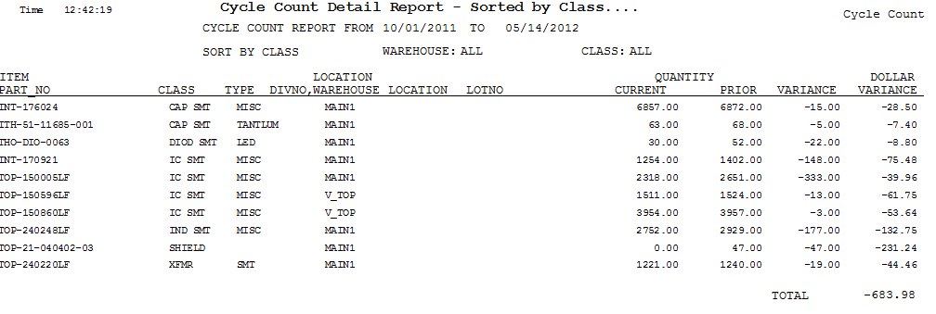
When all this is established, then the detail report will show ALL items that were cycle counted, the prior to count quantity, the counted quantity, and the variance (change in count or cost).

However, this report can contain a LOT of data. In order to be able to focus on potential problem parts, it is easier to use the summary report. This report only shows those items which fall outside the tolerance set for the particular ABC code that the item is. In this way, the user can be concerned with the counts that may represent a serious threat to the accuracy of the cycle count, and inventory control in general.

In the example shown here, the total variance from the period selected was only $37.30, and further investigation would probably not be needed. But if there was a very high value on this report, then examination of the detail values would be in order.



