Within the management and definition of each inventory part, there is a tab called "MRP Info". In this page, there is a provision for entering "Pull In Days” and "Push Out Days". These parameters may be thought of as filters for MRP Order Actions when the requirement dates for the parts changes.

The Push Out value (in days) is the number of days that the required date, base on MRP, may be pushed out (required later than the original date) but will not result in a change order to move the required delivery for the item involved.

Consider the following diagram. The sales order requirement is a date at the far right of this diagram. Preceding that is the amount of time needed in shipping in order to meet the required date.
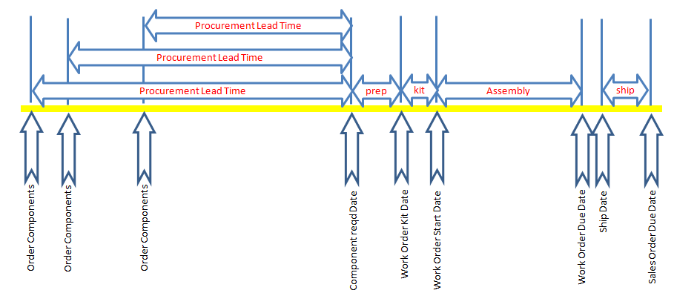
Then, working right to left, there is the time required for packing the product, the time required for the work order to assemble the product, the time to kit the components for the work order, the time to prep components for the line, and then the procurement time to receive the components after order. In this example, there are three component lines to demonstrate that there will be different required dates to order components, based on the component lead times. Each of these leadtimes are associated with the individual components and subassemblies, as well as the main assembly itself.

Now suppose that all order actions generated by MRP have been executed - for both purchase orders and work order(s).

Then the customer requests that the delivery date be pushed out a period of time, say two weeks.

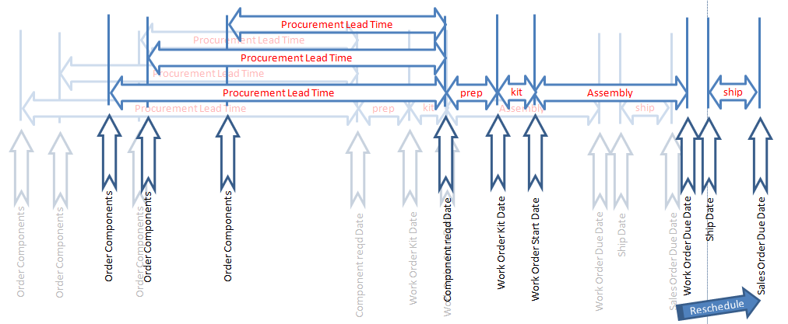
This would slip the schedule for all action items accordingly, with no push-days for the components or assemblies.

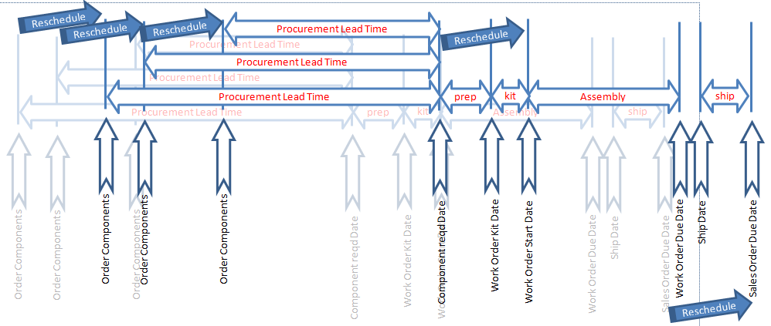
Now this is what MRP would then do - create change orders to also push out all of the components and work orders for that required assembly. Depending on how much time the requirement is pushed out, it may be inappropriate to also make all of these changes. So that's where the Push-Out days helps diminish the amount of overhead in managing inventory.

Let's say that we have the requirement pushed out by the customer by four days. And in the assembly being sold, it has a push-out day’s value set at seven days. The net effect of this situation is that while the shipping date for delivery of the product has moved out, the work order, and the components for the work order do not require any further action because of the push-out days for the assembly.

Of course, this means that there will be inventory on hand for the ordered product for the four days the customer had moved out the delivery date.

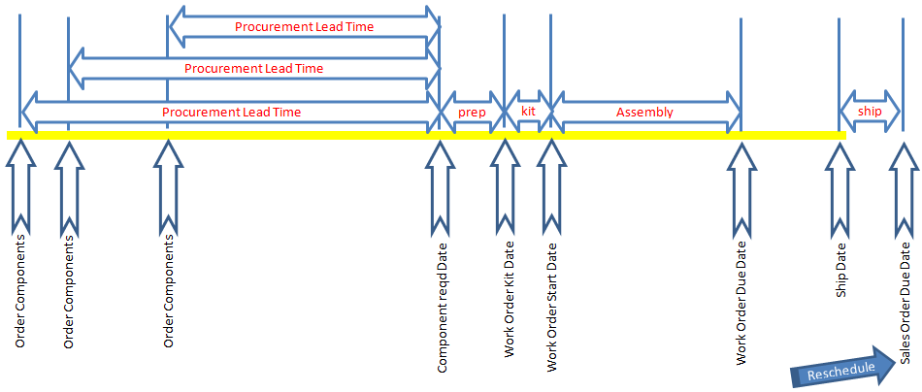
But with some consideration for the value of holding the inventory, and the value of expending the time to reschedule all of the needed components and subassemblies for the product, there will be a break-even point at which it costs less to make all of the changes than to hold the inventory. That's the point at which the push-out days should be set.

Additionally, while the foregoing considerations are applied to the assembly of the work order, there may be push-out days assigned to each component used in the assembly. There may be some components that are very difficult to obtain, and it isn't desirable to bounce around such orders. So such items may have a long push-out time. On the other hand, an item may be very expensive, and the cost of inventory would dictate that the item should closely follow the required need date, so it would be appropriate to have a minimum push-out for such a component.

It is up to the user to decide which components should have push-out filters applied, and for what period of time.

This concept also is applied to the Pull-in day’s parameter. Except that in the case of the customer pulling forward their required date, it is a greater imperative that the work orders (thus the assembly) be pulled in to match the earlier due date. So the assemblies should probably have a minimum number of days to be sensitive to earlier demands.

Some components, on the other hand, may have an order policy in weekly or monthly lots. These items may be less sensitive to earlier requirements, and as such might have a pull-in requirement about half the number of days of the order policy. Again, the overhead consumption in responding to customer modifications in their delivery dates should be weighed against the cost of change orders to purchases, or maintaining inventory.

