- Here is the sample product and BOM that we will be using in this scenario. 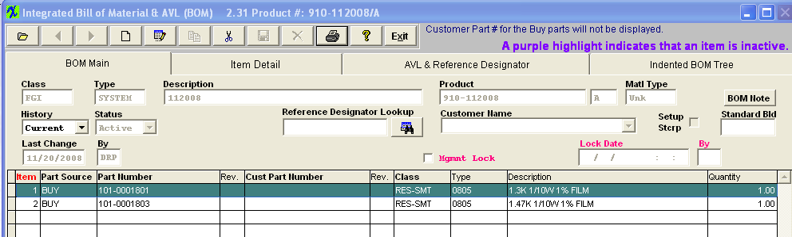
- Sales Order and the Work Order are created within the system. 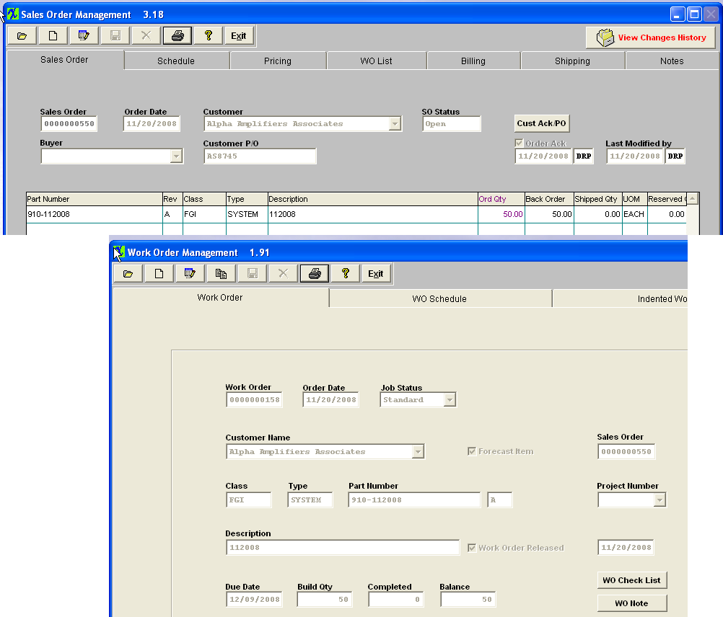
- Run MRP and it is providing the correct Release PO actions for the Buy parts. 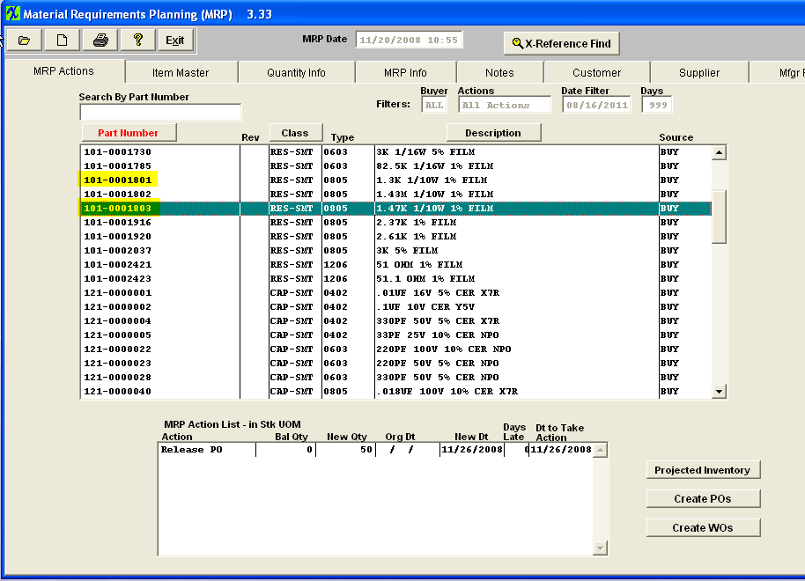
- The Make items is also properly giving the No WO Action message at this time. 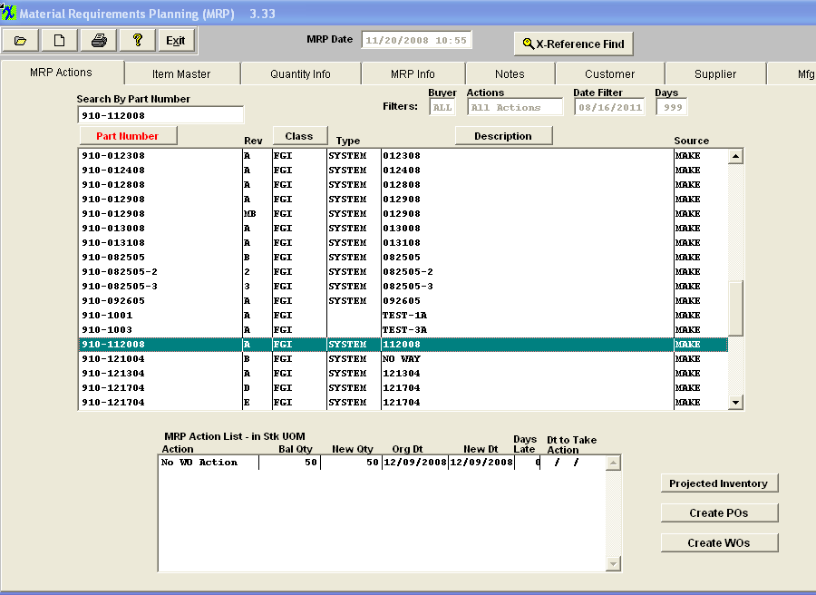
- The Buy components were since received into the system and picked to the Kit. 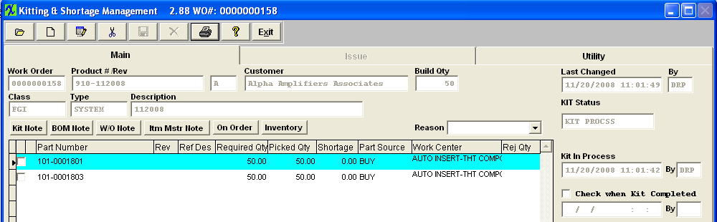
- Re-run MRP and the Make product is properly showing Order kitted. The Buy parts are properly no longer displayed on the MRP. 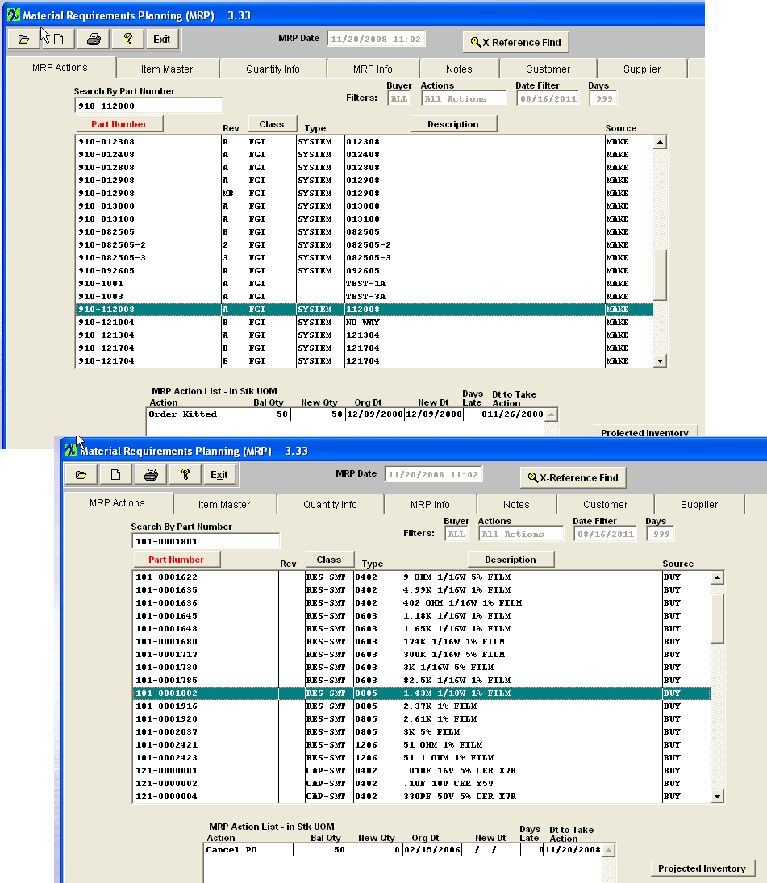
- The product was all moved into FGI and the Packing List/Invoice generated. 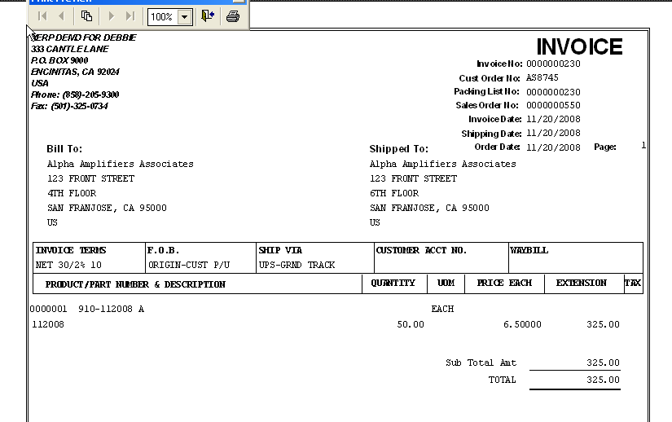
- Then the customer returns 11 of the 50 that was originally shipped to them. The following RMA is then generated in the system. 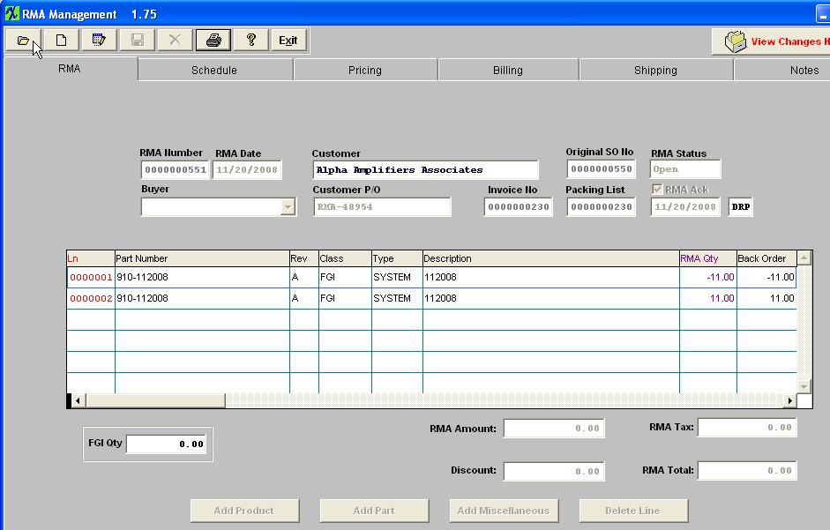

- Run MRP and at this time you will see a ReworkFirm action for the Make product itself and the Projected information will reference the RMA#. IF the users see the ReworkFirm action for a Product they should know that this does not require any action on their part at this time. 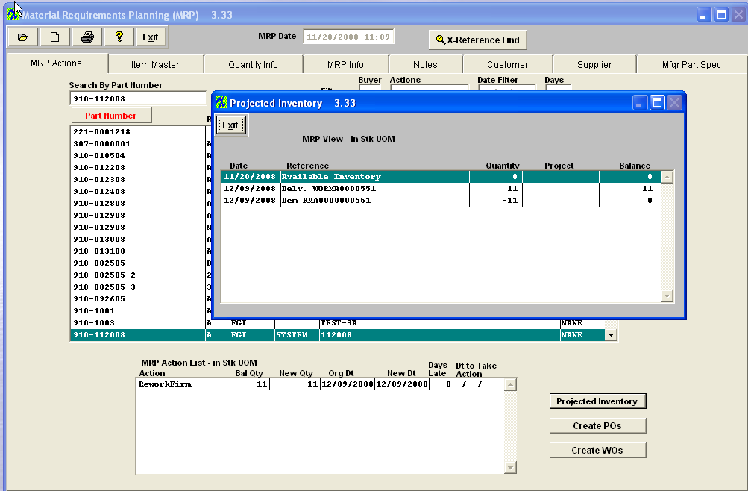
- Confirmed that the MRP has properly not generated any actions for the Buy components at this time. 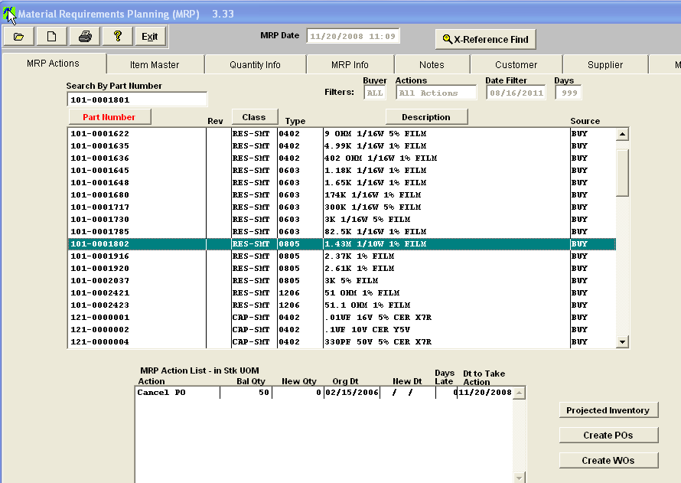
- RMA Receiver is generated in the system to bring the Product back into the system for reworking. 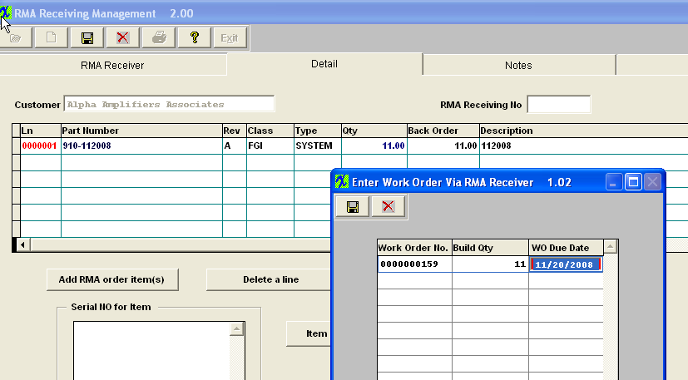
- Upon the creation of the Rework Work order the system will automatically add the product itself to the Kit as a line shortage picked in full. None of the components will be exploded out. 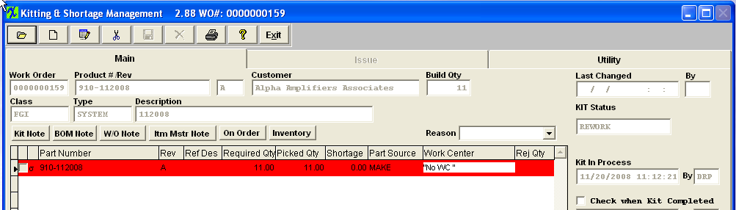

- Run MRP the Product is still properly referencing “ReworkFirm” no action required. You can see that the Projected screen is now also referencing the Rework Work order that was generated upon saving the RMA Receiver. 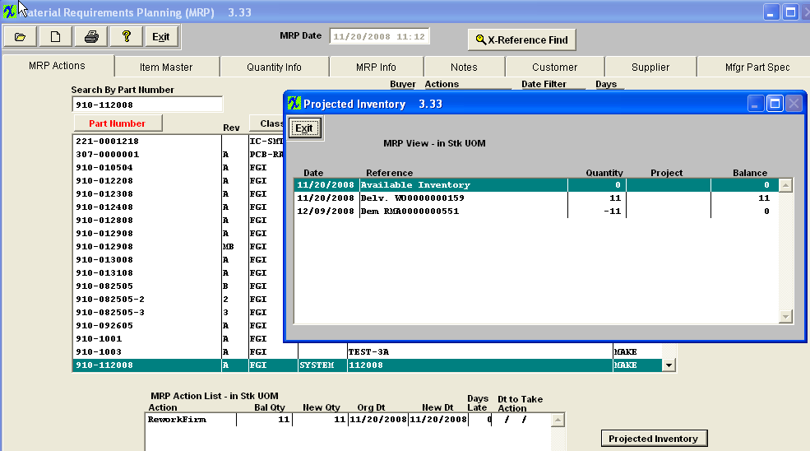
- Confirmed that the Buy Components properly still do not have any actions in the system. 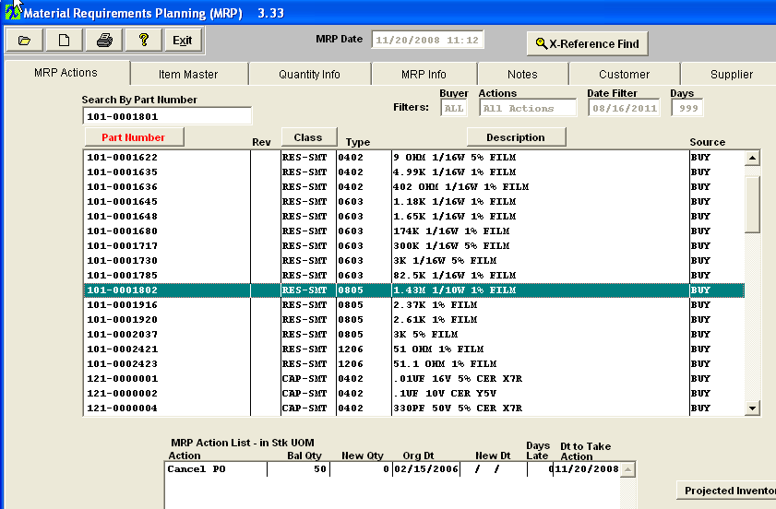
- The Rework Workorder is then moved through Shop Floor Tracking into FGI. Confirmed at this time that MRP is properly no longer showing any actions for either the Product or the Components. 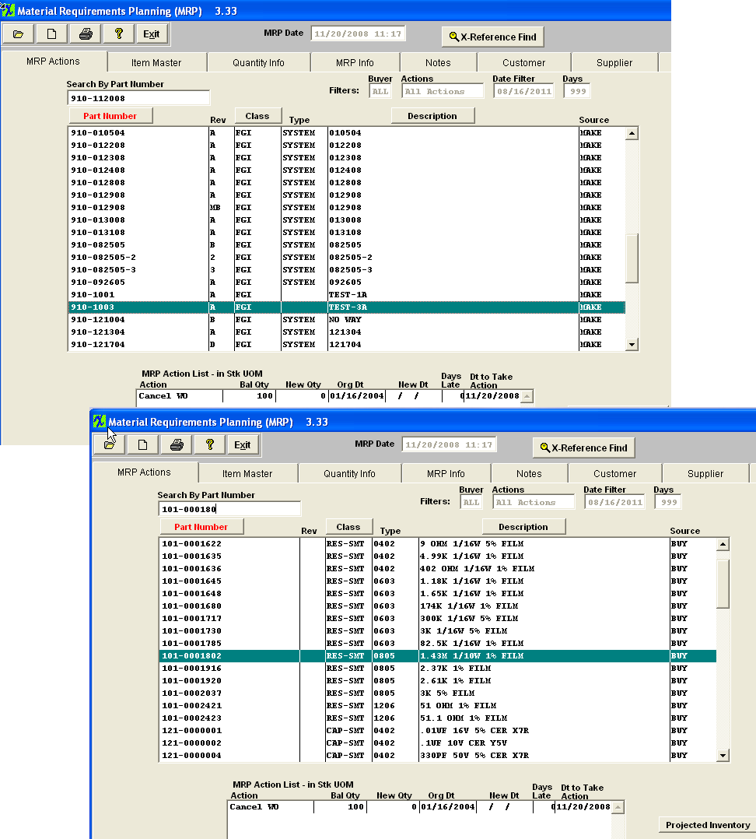

- Now if the users accidentally ship those 11 against a different order or had to scrap them out within Shop Floor tracking. Upon Running MRP again the system will properly see that there is currently 0 on hand for the Make Product itself and that they still have the remaining balance on the RMA to ship back to the customer. 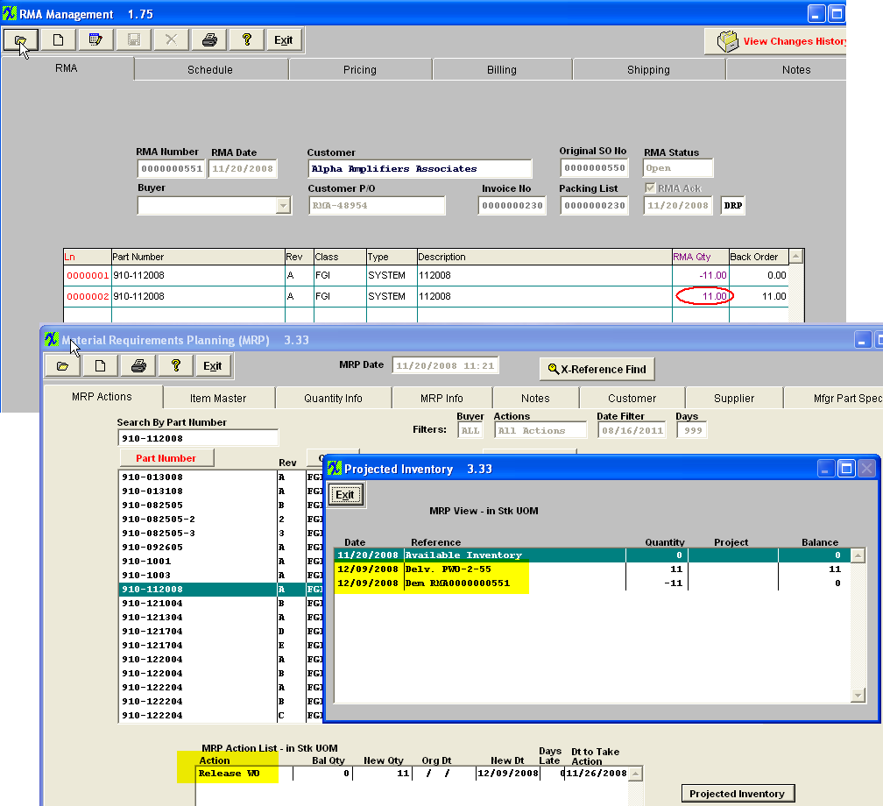
- MRP will also then properly give Release PO actions for the components, so the product can be build to ship the remaining balance on the RMA order. 

