- Created a Invoice for 500.00 and posted the Transaction. 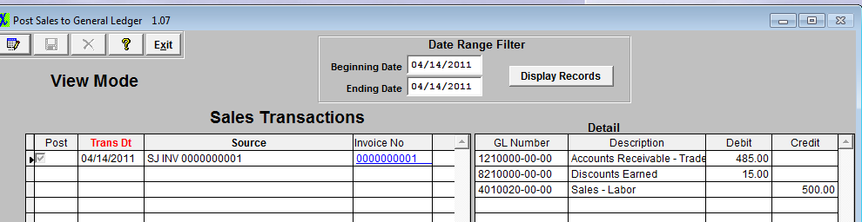
- AR Aging as of at this time. 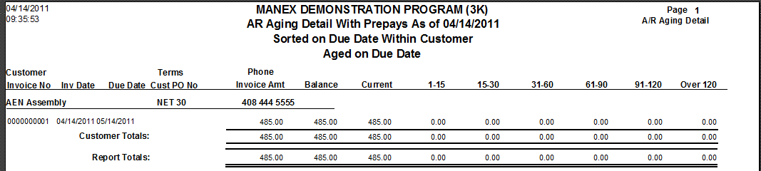
- Here is the Trial Balance. The 1210000-00-00 matches the As of report. 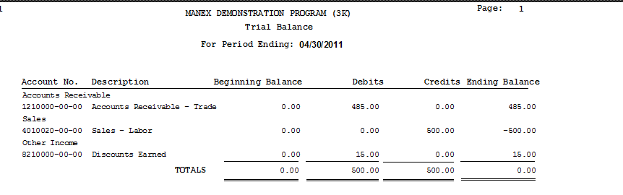
- Process a prepayment for $1000.000. 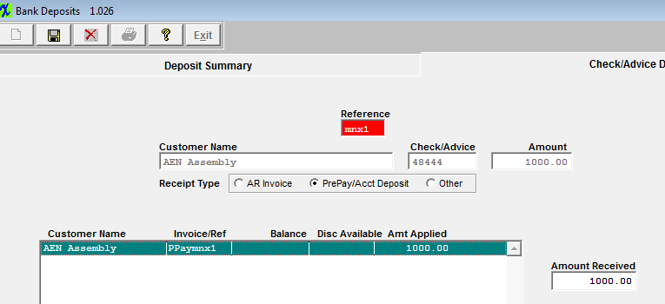
- Here is the resulting transaction. 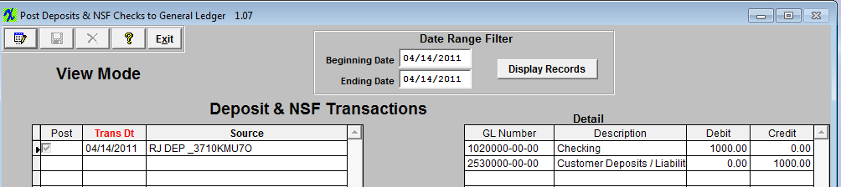
- Ar Aging As Of report. 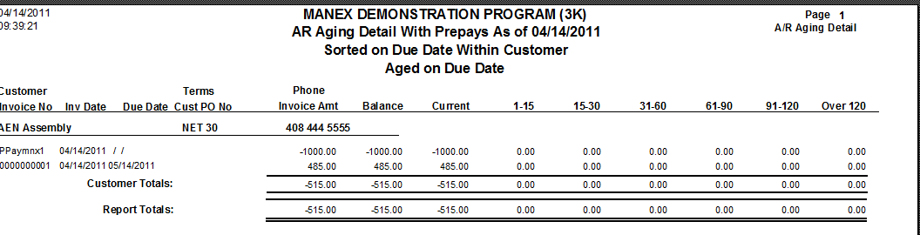
- The trial balance for 1210000-00-00 no longer match. Due to the fact that we are including the Prepayment in the As Of Report. So really the user should be also considering the Customer Deposits gl account when comparing the two reports. 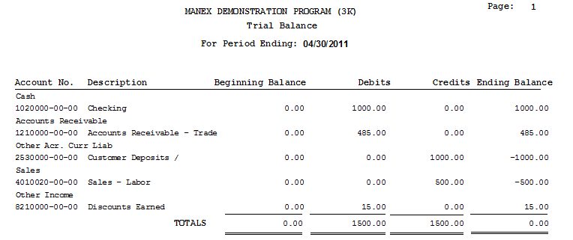
- I am then going to process the AR Offset. 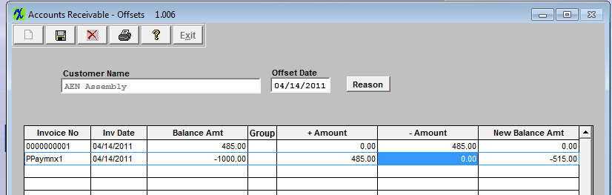
- transaction that resulted. 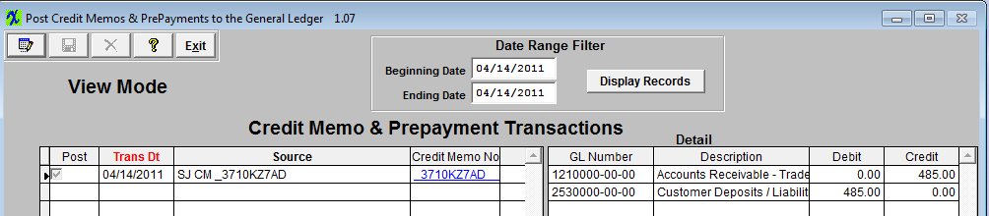
- trial Balance. 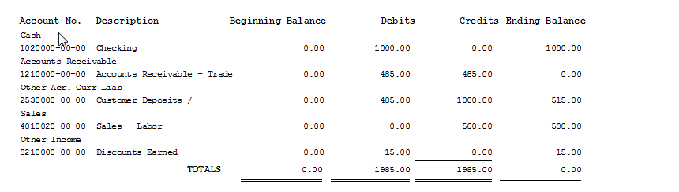
- Aging As Of. 

