1-6 Will cover some snapshots of Accepting items into stock through PO Receiving, and the resulting transactions that affect the Un-Reconciled Receipt accounts.

- The Purchase Orders were created and received into inventory. 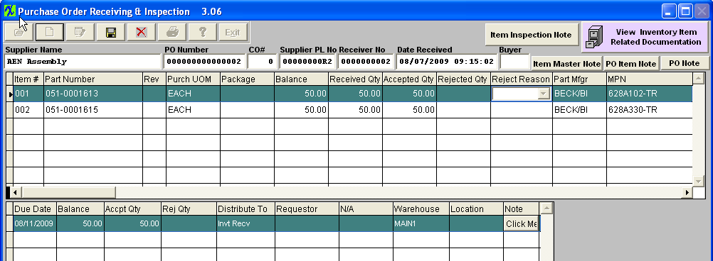
- At the time you accept the inventory into stock there is an GL transaction that is generated that will Debit your Stock GL account and Credit the UnReconciled Receipt account. 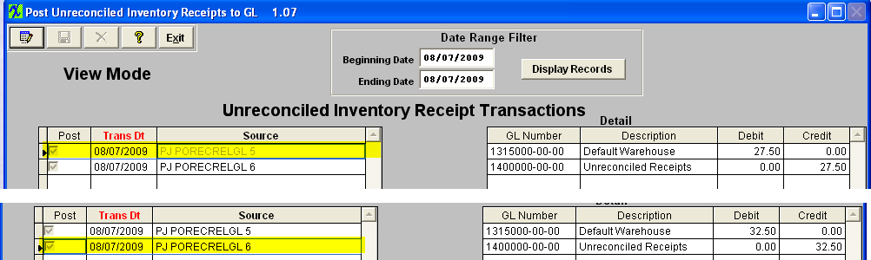
- The Trial Balance report displays the following at this time. 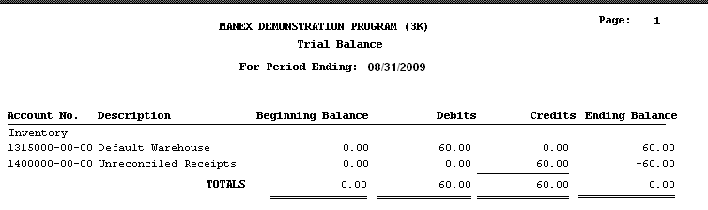
- Process the PO Reconciliation through the system. 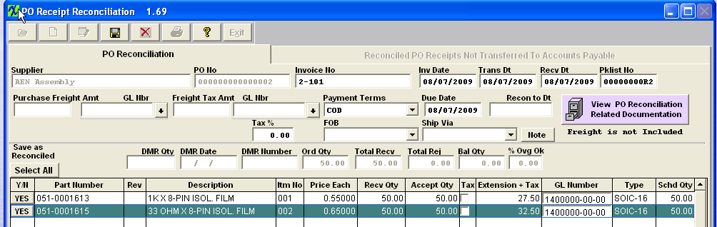
- Upon saving the PO Reconciliation and transferring it to AP, the following GL Transaction would be generated within the system. 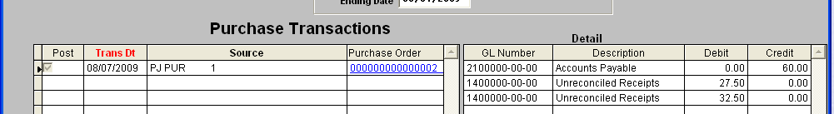
- The trial Balance updates, showing that the Unreconciled Receipt account now has a 0.00 balance and that the balances reside within the Accounts Payable and Stock accounts. 

