1-13 Shows basic procedure followed for processing an RMA through the system where both of the items DO NOT have a $$ associated with them.

- Create a RMA order – this time both items are at 0.00. 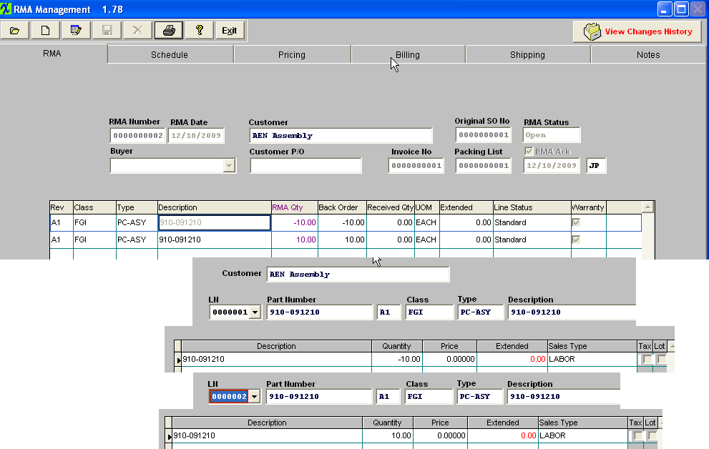
- The RMA Receiver is generated. 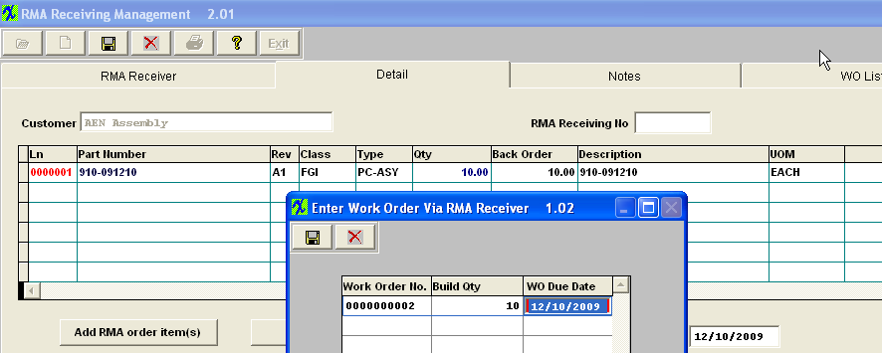
- Find and Approve the 0.00 Credit Memo. 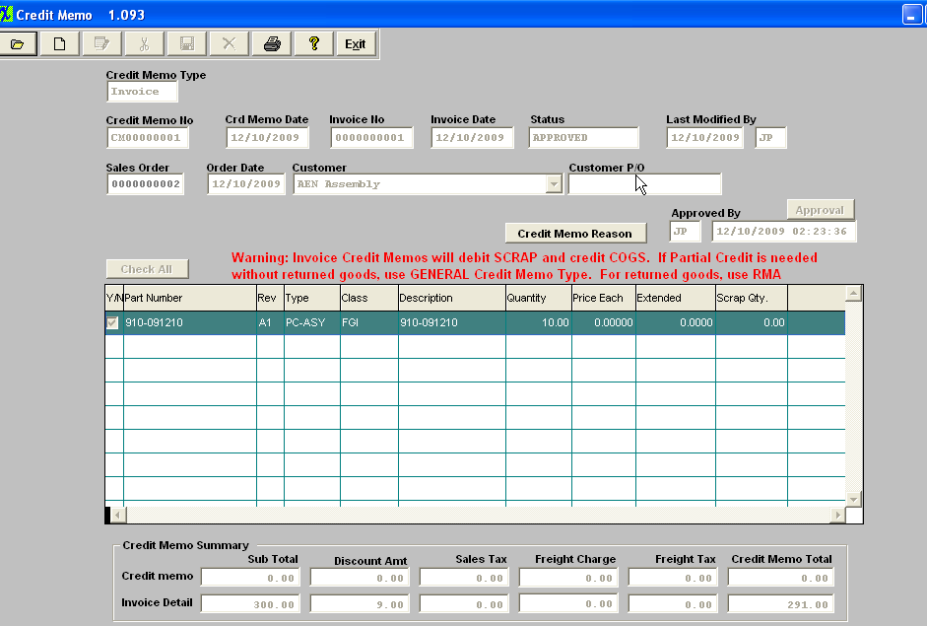
- Below is the resulting Transaction for approving the 0.00 credit memo. 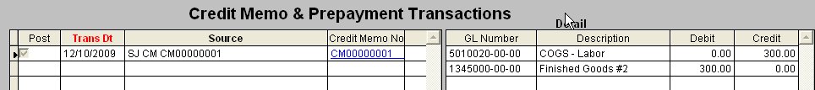
- The Trial Balance updates as follows. 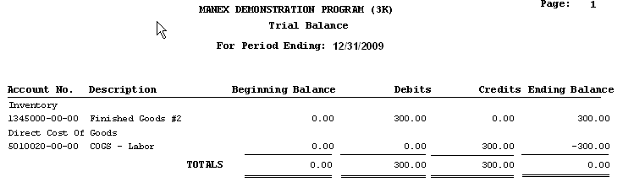
- As soon as the RMA Receiver was saved, the following transaction was generated. 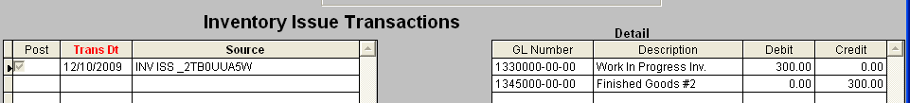
- trial Balance updates as follows. 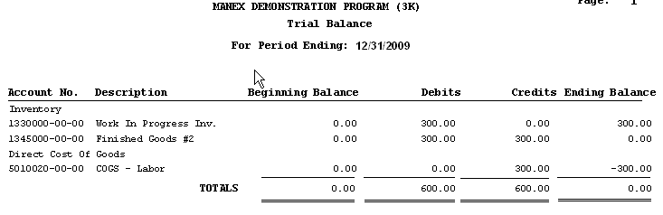
- Move the Rework Work Order through Shop Floor Tracking. 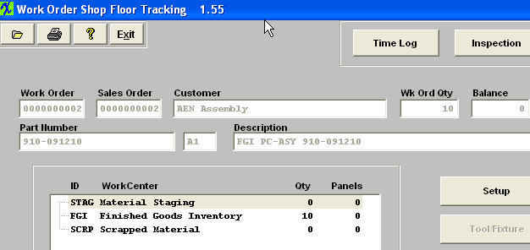
- The Below Inventory Receipt transaction is generated. 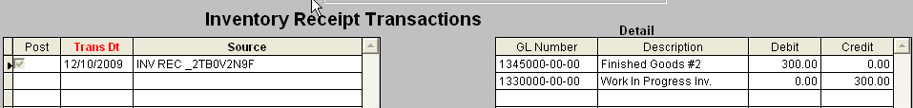
- Trial Balance updates as follows. 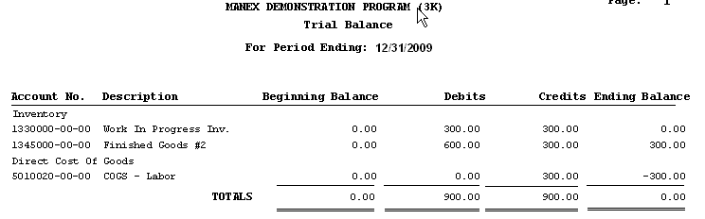
- Shipped the reworked product back to the customer and invoice for it at no charge. 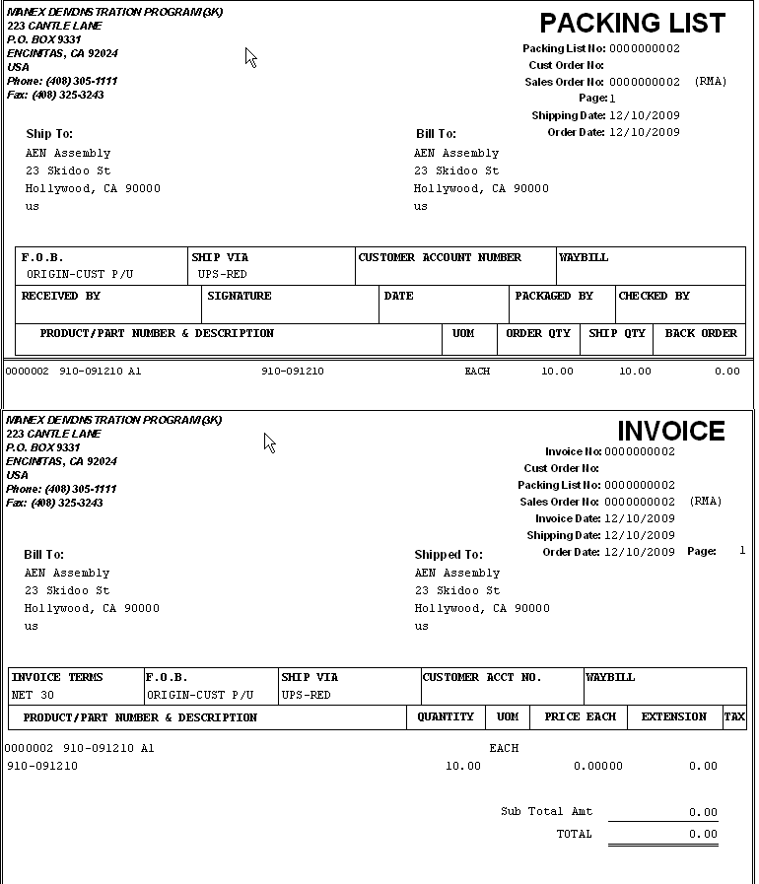
- The below sales transaction is generated as soon as the invoice is printed. 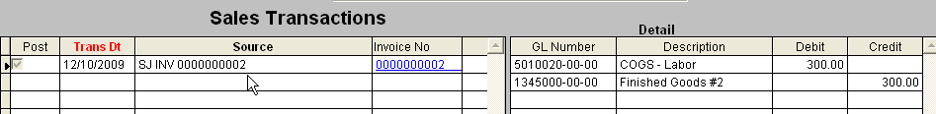
- Trial Balance is updated as follows. 

