1-14 Shows basic procedure followed for processing an RMA through the system where both of the items have a $$ associated with them.

- Then the customer returns 10 of them on a RMA. This Scenario, we will Enter pricing information into both the RMA items. 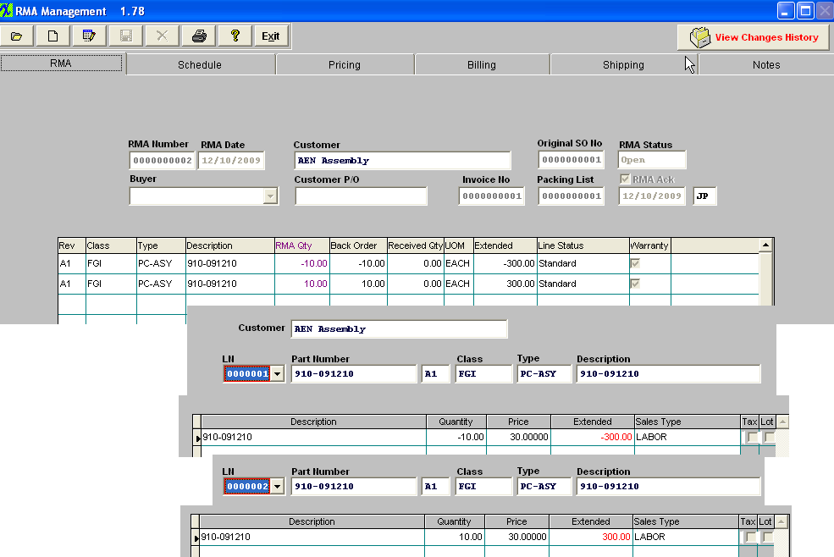
- The RMA Receiver is generated. 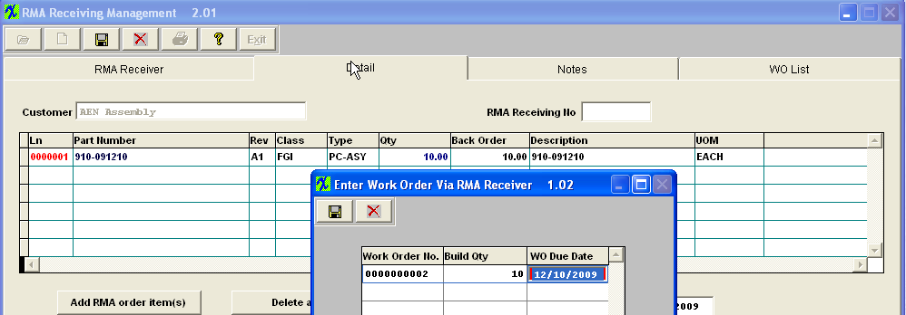
- the Rework Work Order, automatically picks the product itself to the kit. 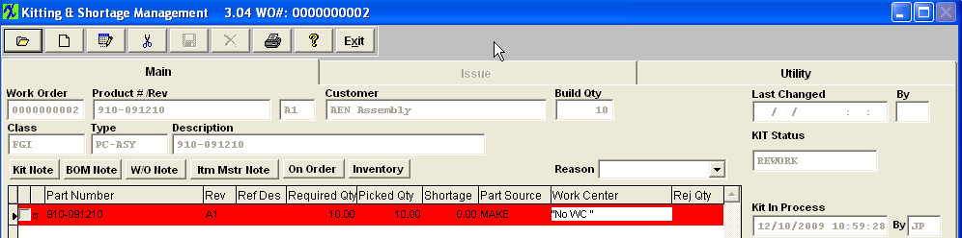

- Here is the transaction that is created upon saving the RMA Receiver. 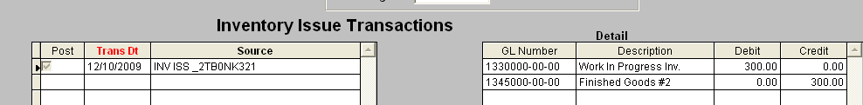
- Trial Balance updates as follows. 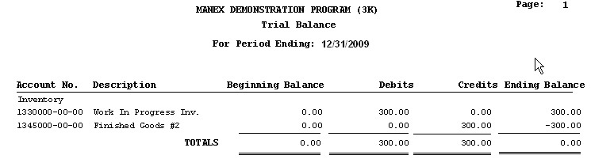
- Approve the Credit Memo that was generated. 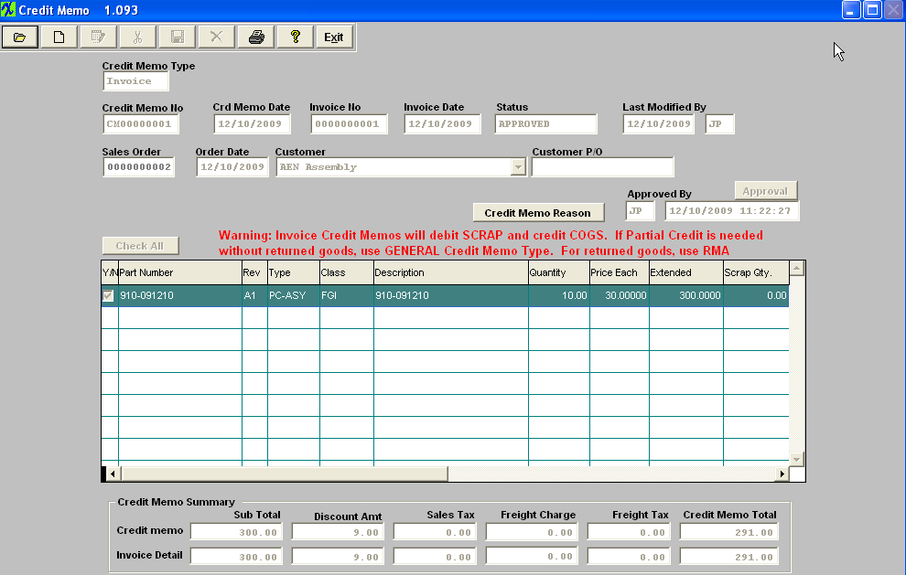
- Transaction that results after the CM was approved. 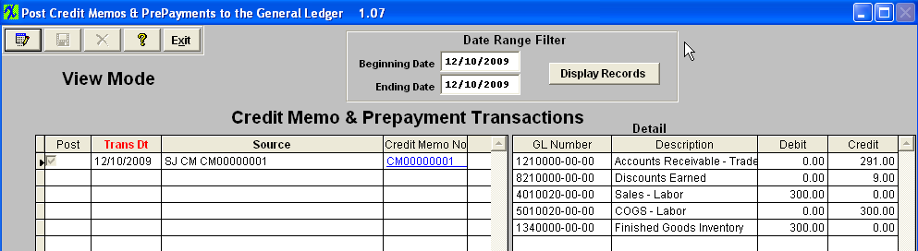
- trial Balance updates as follows. 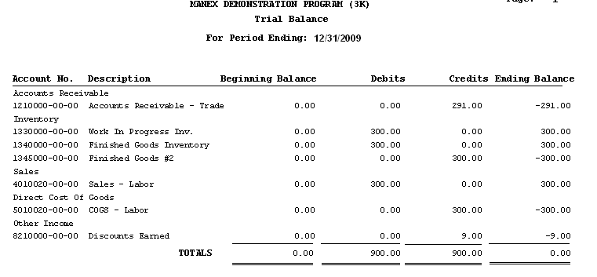
- Move the Rework Work Order into FGI. 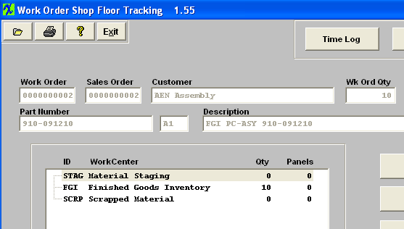
- Here is the resulting Inventory Receipt transaction. 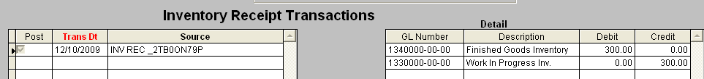
- Trial Balance updates as follows. 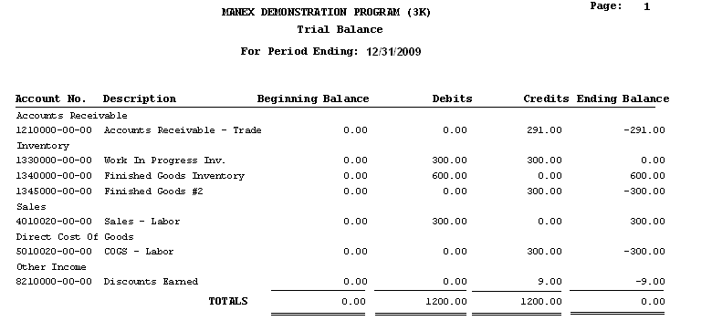
- Ship the reworked item back to the customer and invoice for it. 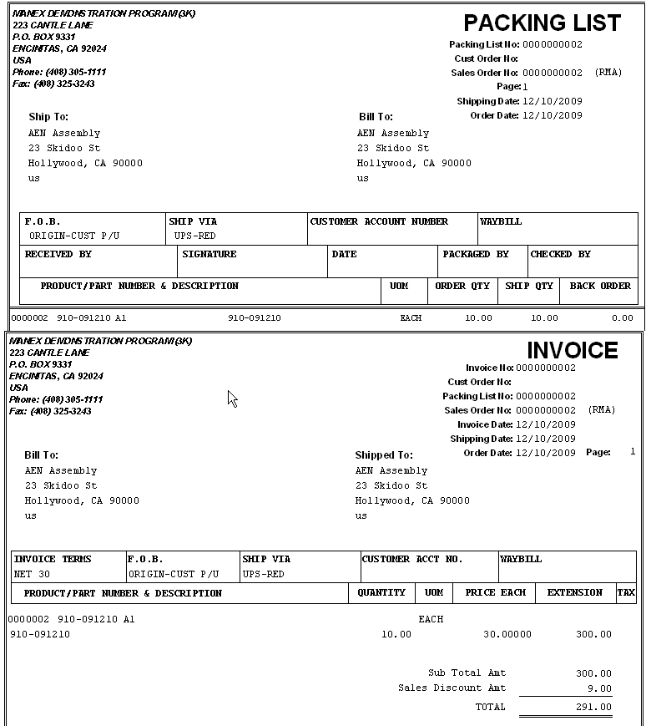
- The resulting Sales transaction. 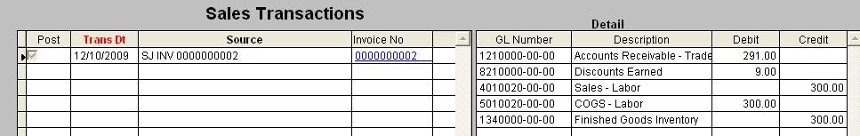
- Trial Balance updates as follows. 

