- Create a PO for a inventory part that has a UOM Yard to In Conversion within the system. 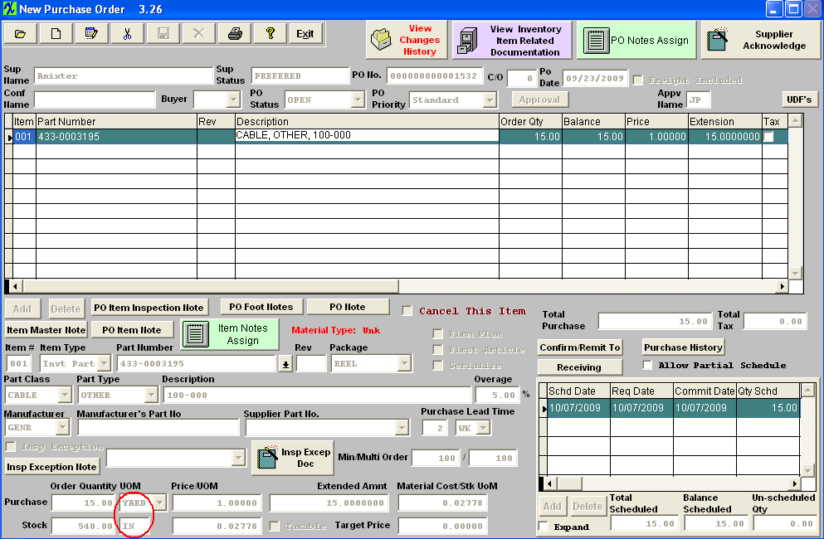
- Accept into inventory and an unreconciled receipt is then created. 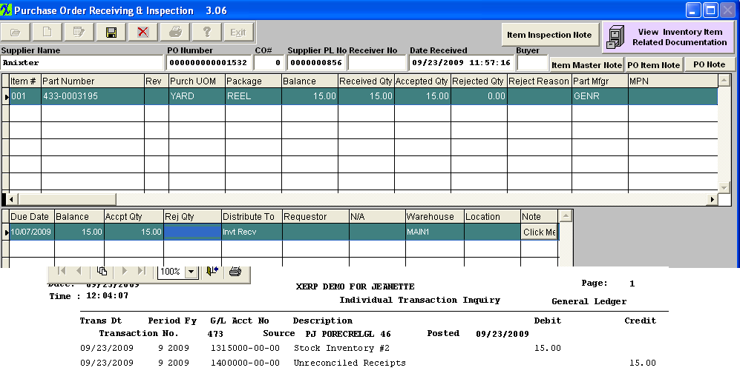
- Inventory issued out qty of 10. 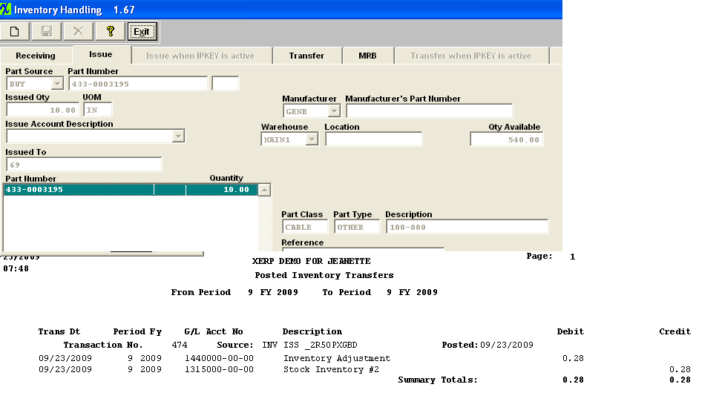
- Transaction Log Beginning balance is correct at this time. Beginning balance is 0.00. 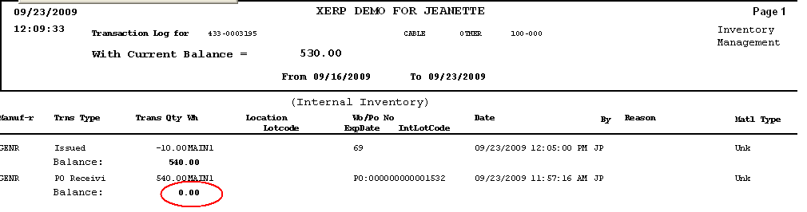
- Reconciled the receipt within PO Reconciliation. 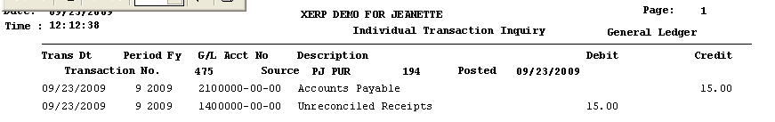
- Go and change the Stock/Purchase UOM while there was still stock on hand. The system properly displays a warning. 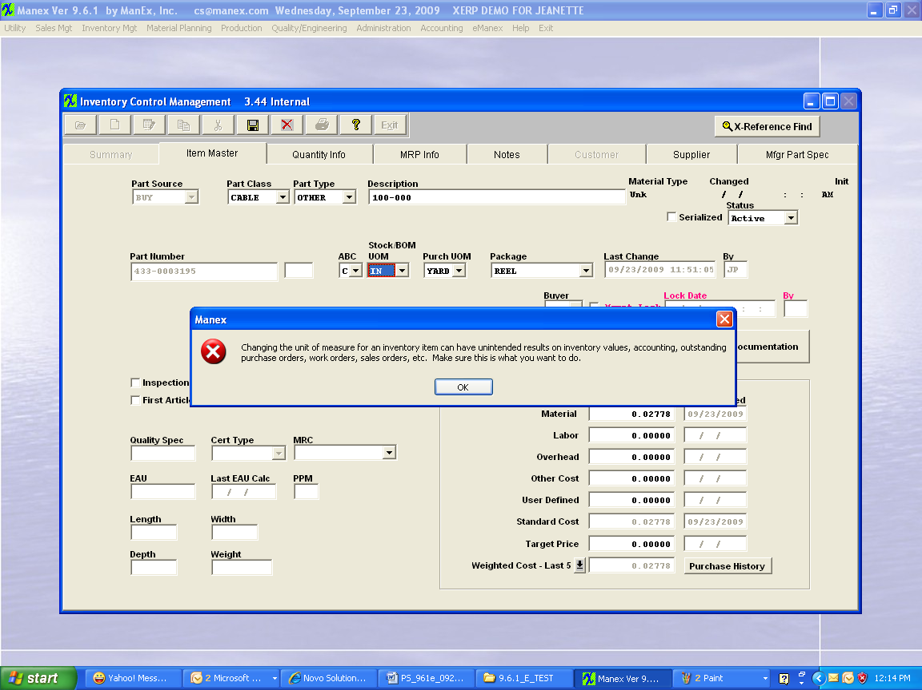
- I ignored the warning and made the UOM change anyhow. 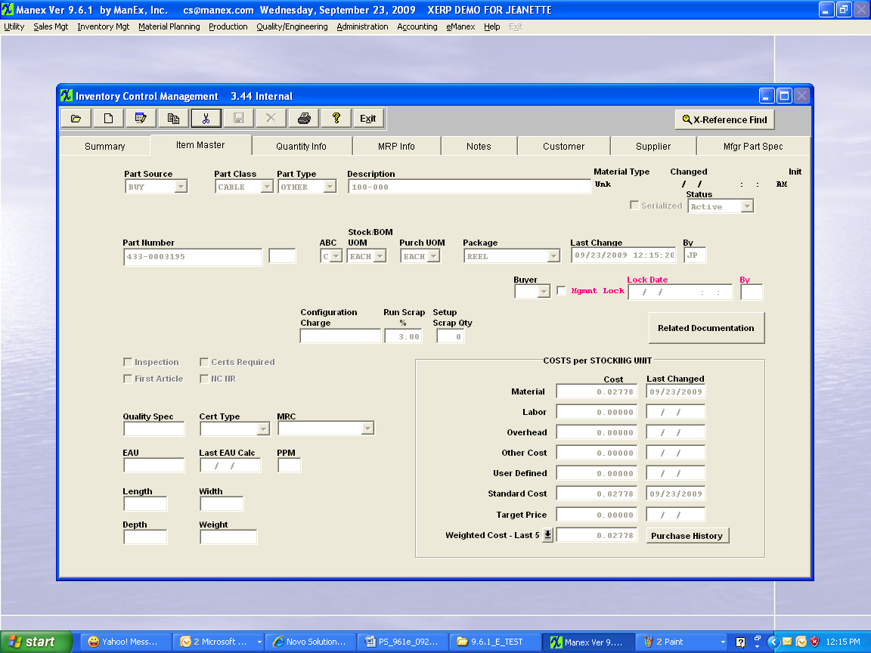

- The inventory transaction report then updates as follows. You can see that it now has a Beginning Balance of 525 and also that the PO Receipt changed from 540 to 15. 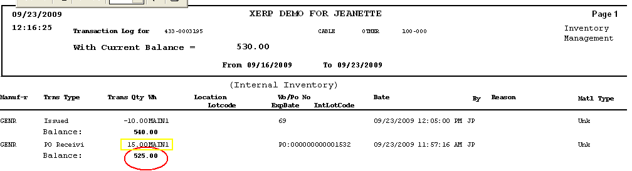
- Issue the remaining balance out of inventory. 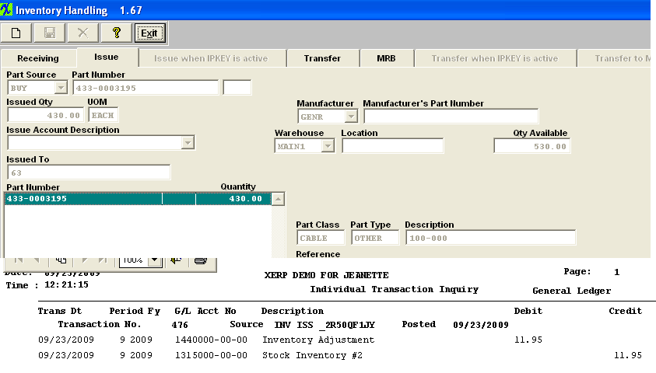
- The report will remain with the Beg Balance of 525. 

