1-15 Shows the procedure that is basically followed for processing a kit through the system and the resulting transactions that hit the GL at each stage.
  - Issue Parts to the Kit
  - Move product through SFT into FGI
  - Create the Packing List and Invoice the customer
  - Create the AP Check to pay the Supplier for the components
  - Create AR Deposit for when the customer paid the original invoice

- Put the kit in process and picked it in full. 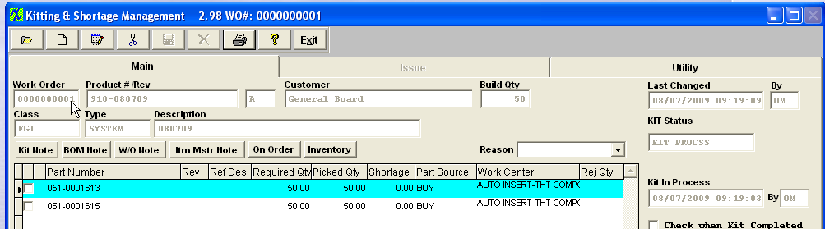
- As soon as you pull the parts to the kit. There Inventory Issue GL Transactions generated. 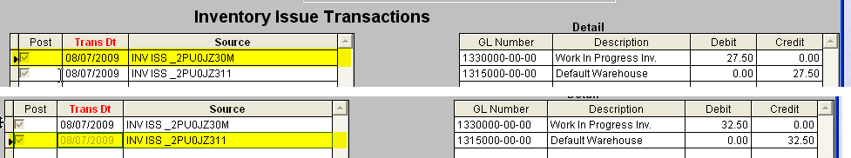
- The trial Balance will show that now you have a 0.00 balance in stock and WIP now carries that balance. (along with Accounts Payable, because you have not yet created the AP Check to the supplier yet) 0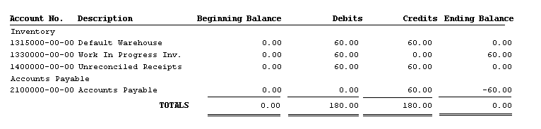
- The users then move the product through Shop Floor Tracking, and all 50 are transferred into FGI. 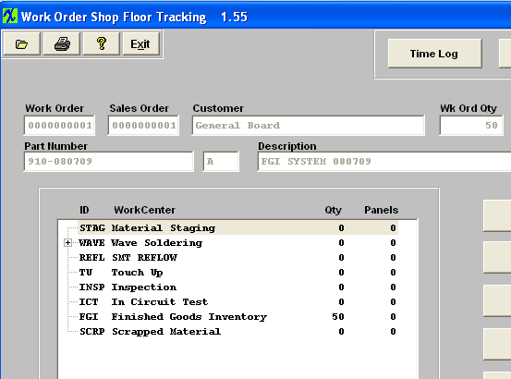
- At the time it is moved into FGI an Inventory Receipt transaction is generated.
- The trial Balance updates. The balance now resides within your FGI account and still the Accounts Payable. 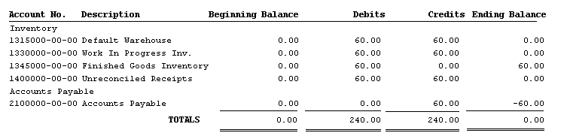
- The users then create a Packing List/Invoice, shipping it to the Customer. 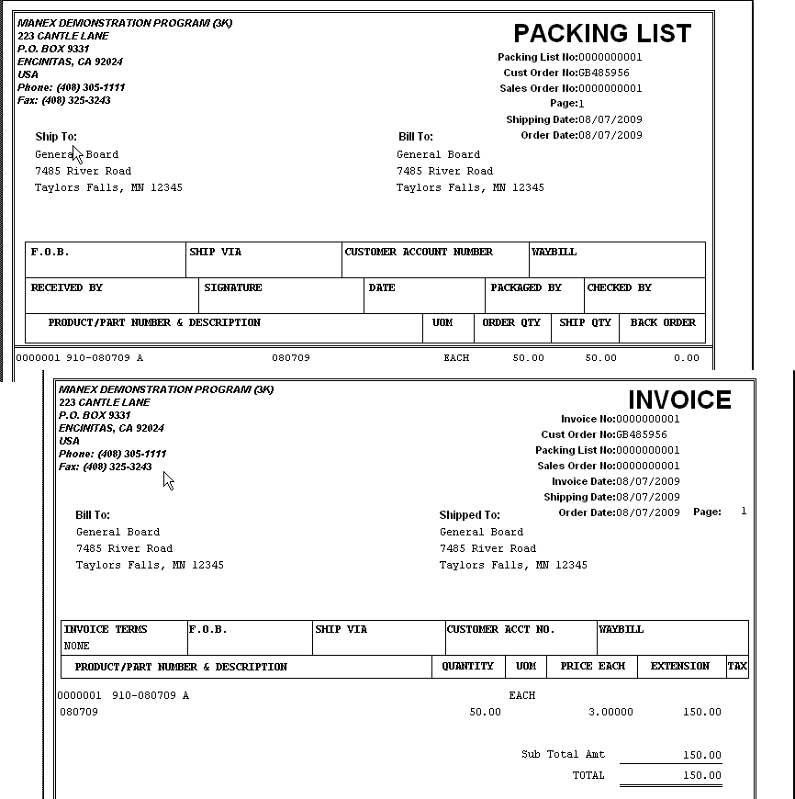
- The following Sales transaction is then generated within the system. 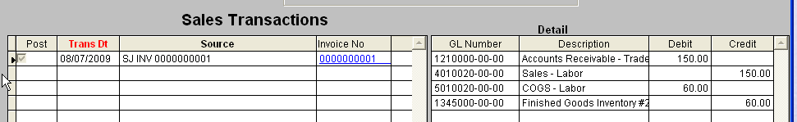
- the Trial Balance updates as follows. 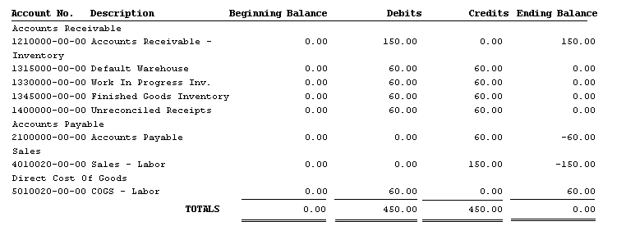
- Printed the AP Check and paid the supplier. 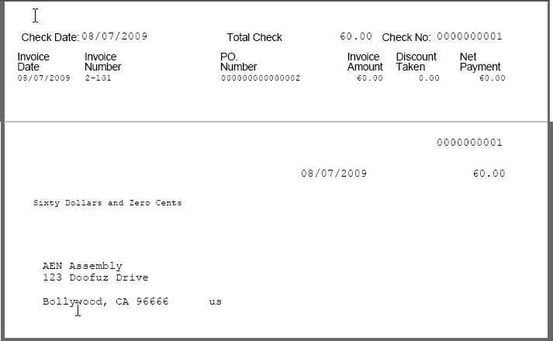
- The AP Check transaction that resulted. 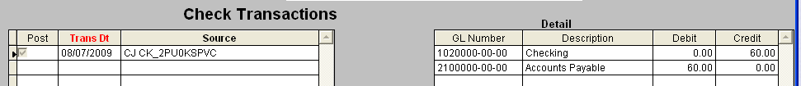
- Trial Balance updates as follows. 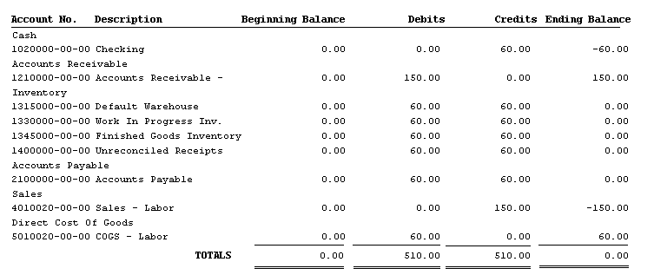
- The Customer pays the invoice and an AR Deposit is recorded within the system. 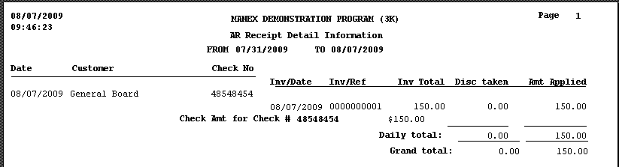
- The AR Deposit that resulted. 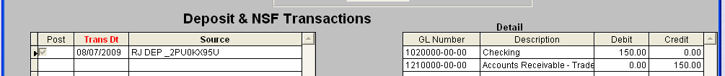
- The trial Balance updates as follows. 

