1-3 Shows the BOM setup and how MRP gave the actions.

- Here is the example BOM used in this scenario. 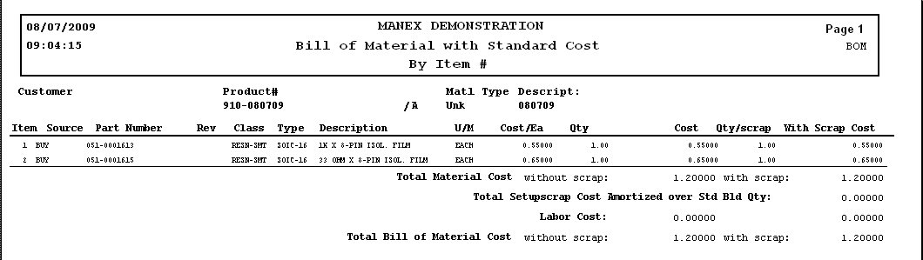
- Created a Sales Order for the Product, Qty of 50. Issued the WO directly from the Sales Order module. 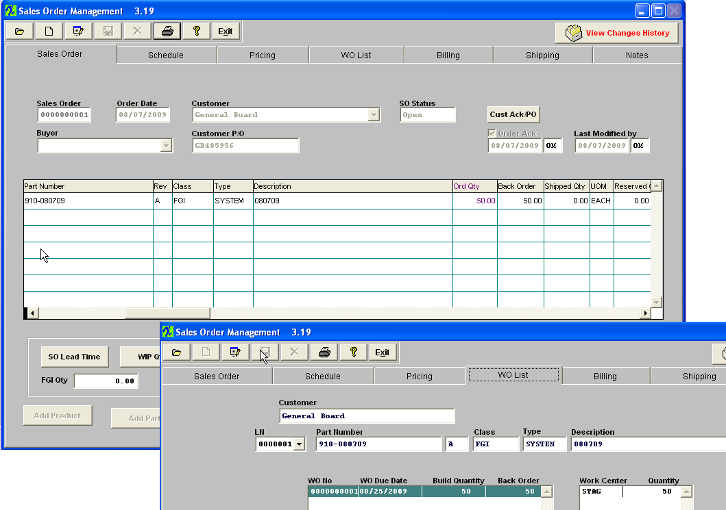
- Run MRP and confirm that the system is properly giving the Release PO actions for the Components, and also displaying a No Wo Action message for the WO action. 

