- Created the Work Order for qty of 113. 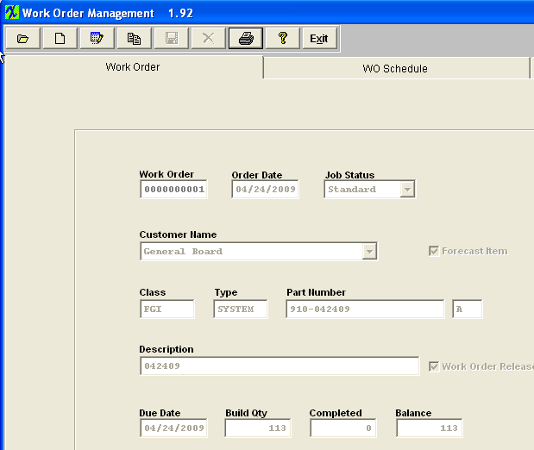
- The kit called for 116 and I picked it in full. 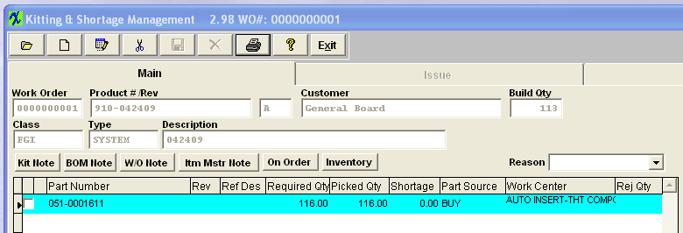
- The user only moved qty of 53 into FGI. 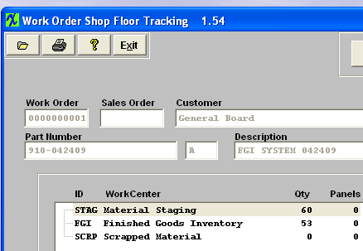
- Reduced the WO Bld Qty from 113 to 53. The system automatically changes the WO status to Closed. 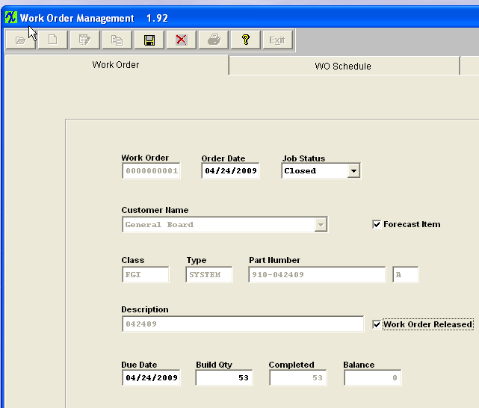
- The users need to change that status back to Standard and save the WO. 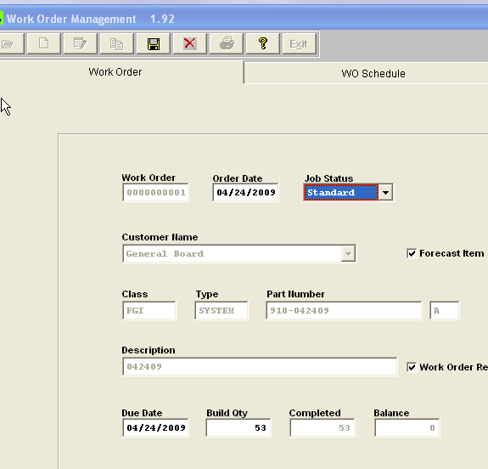
- Return to the Kitting module and update the kit. 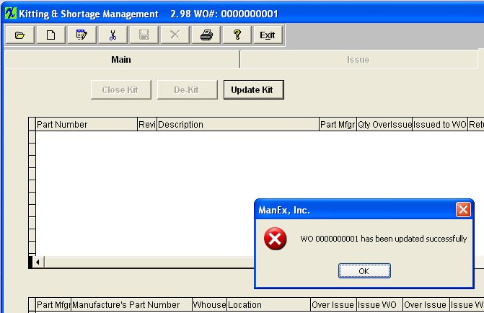
- The main screen will update as follows. 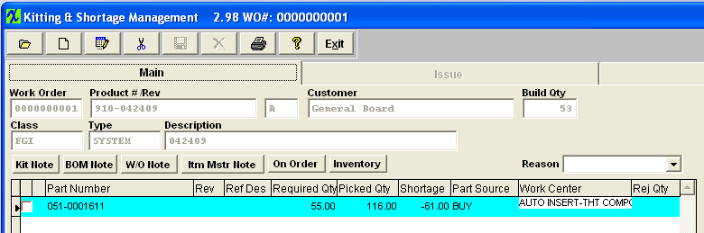

- Return to the WO and edit/save the record without making any changes – the Status will automatically update to Closed.
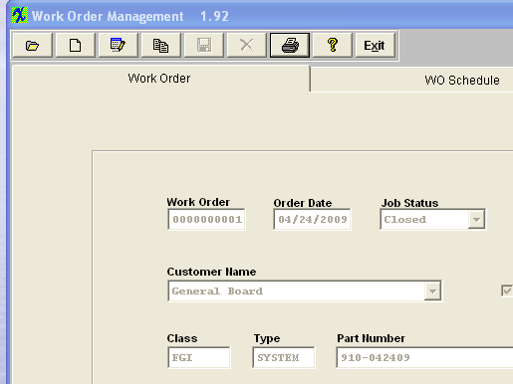
- Now when you close the Kit the parts will be brought in for disposition. 

