- Created an INVOICE credit memo from within the CM Module directly. The Transaction that resulted is correct and does match the warning that we have on screen within the module. Note that when you generate an Invoice CM from within the CM module itself (meaning I did not generated it via the RMA) that the Scrap Qty is then populated.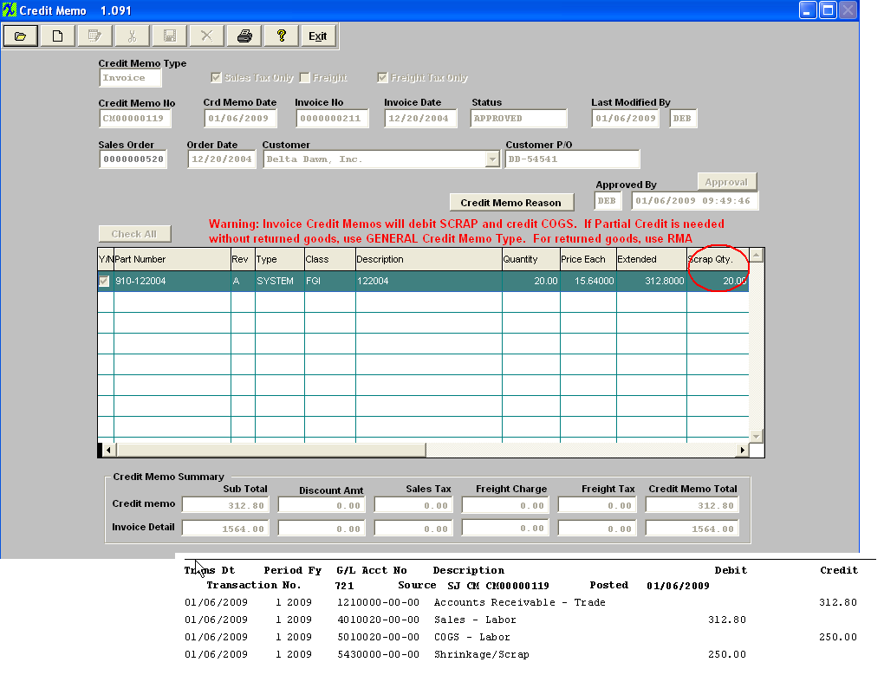
- Create an INVOICE RMA. 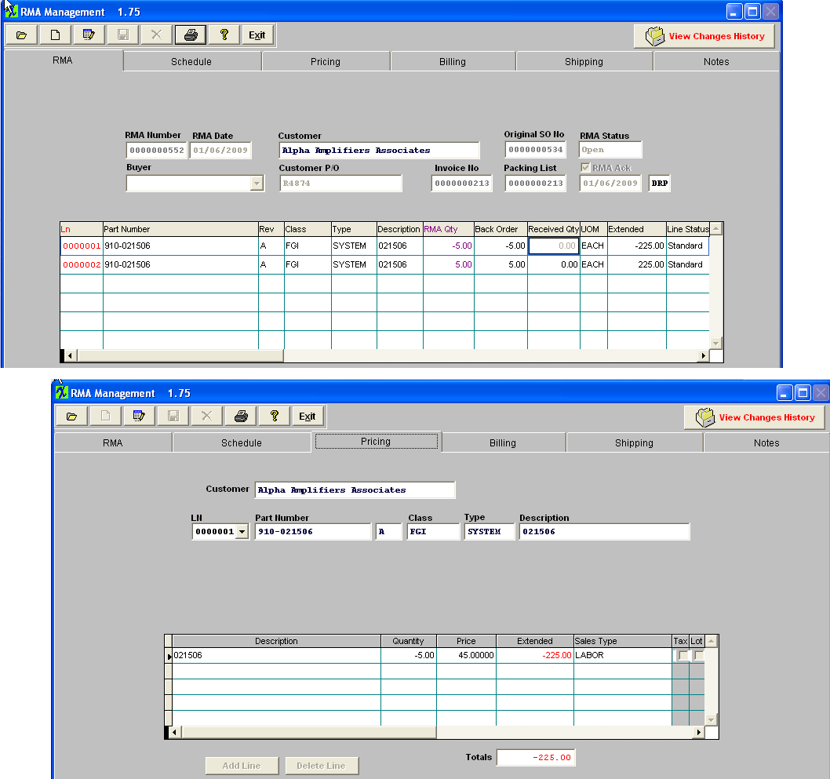
- RMA Receiver is generated. 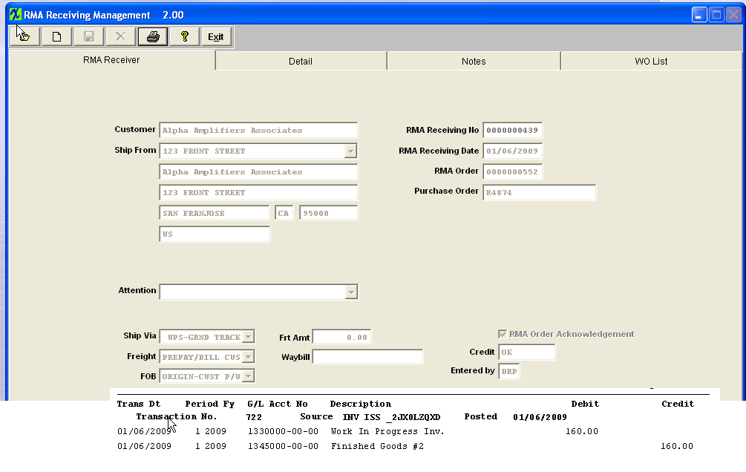
- Approve the RMA Invoice Credit Memo. Notice that for a credit memo originating from a RMA we do not populate the Scrap Qty (which is correct). 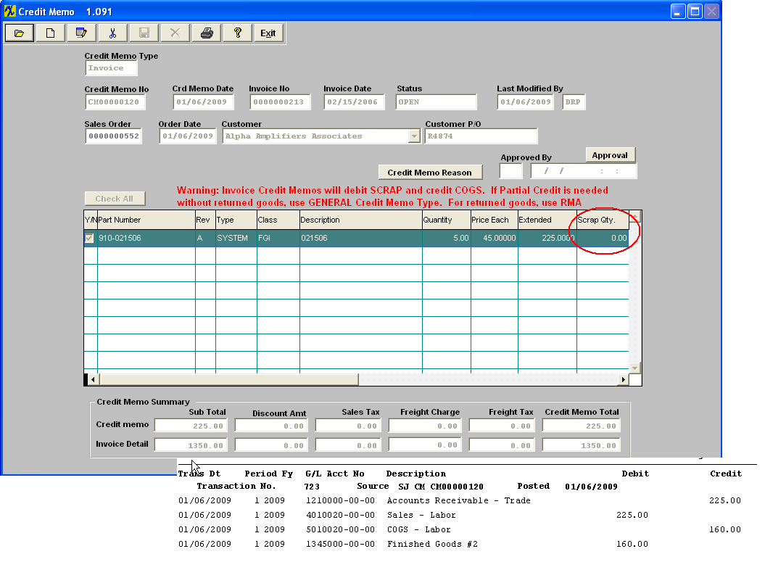
- Move the rwk work order into FGI and the Inventory Receipt is generated. Plus a Config Variance. 

