- setup a new bank account. 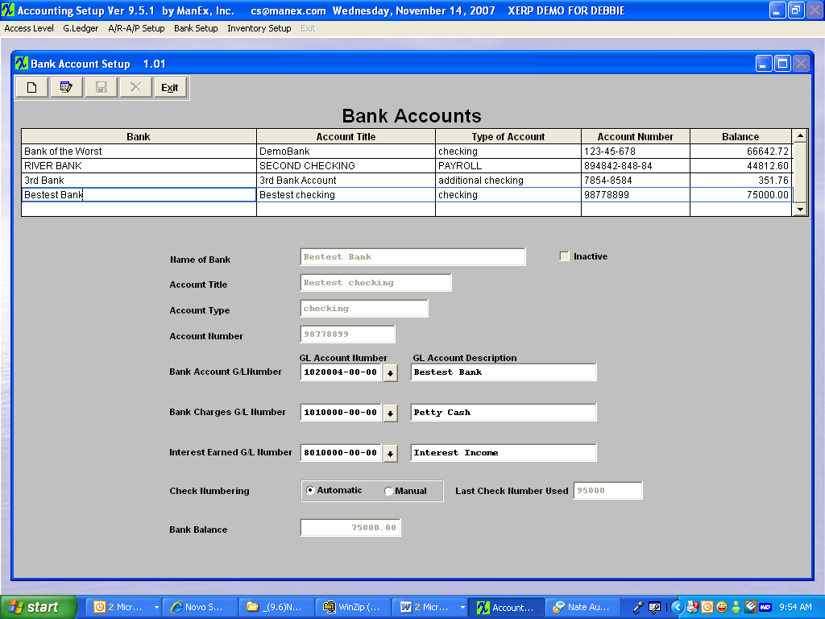
- began processing the 1st Bank Recon through. 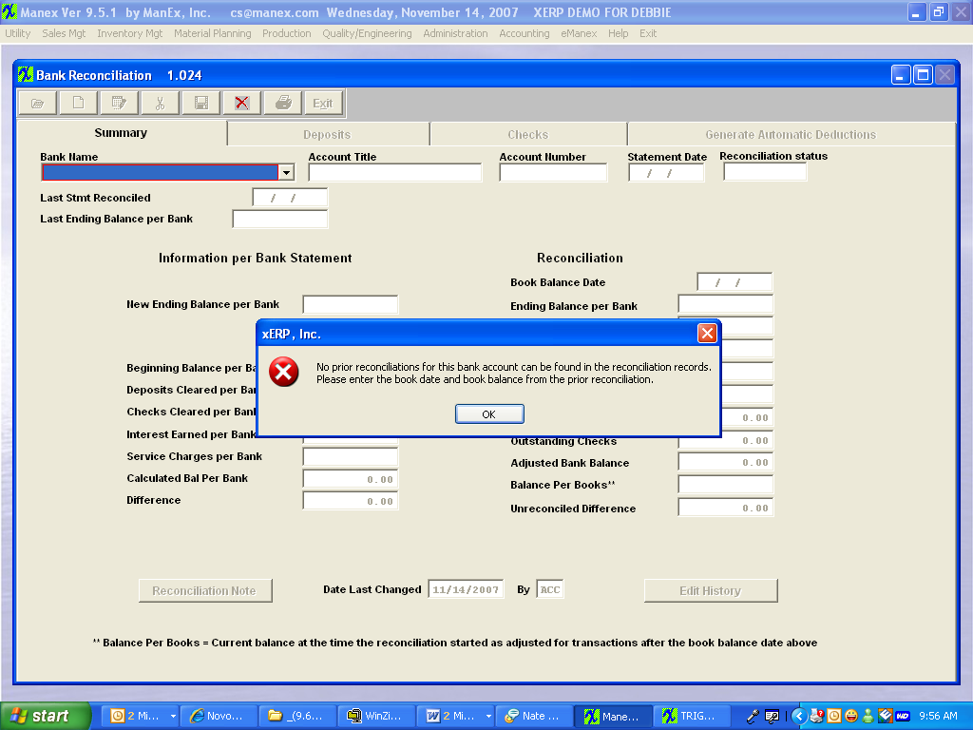
- Populated the following. 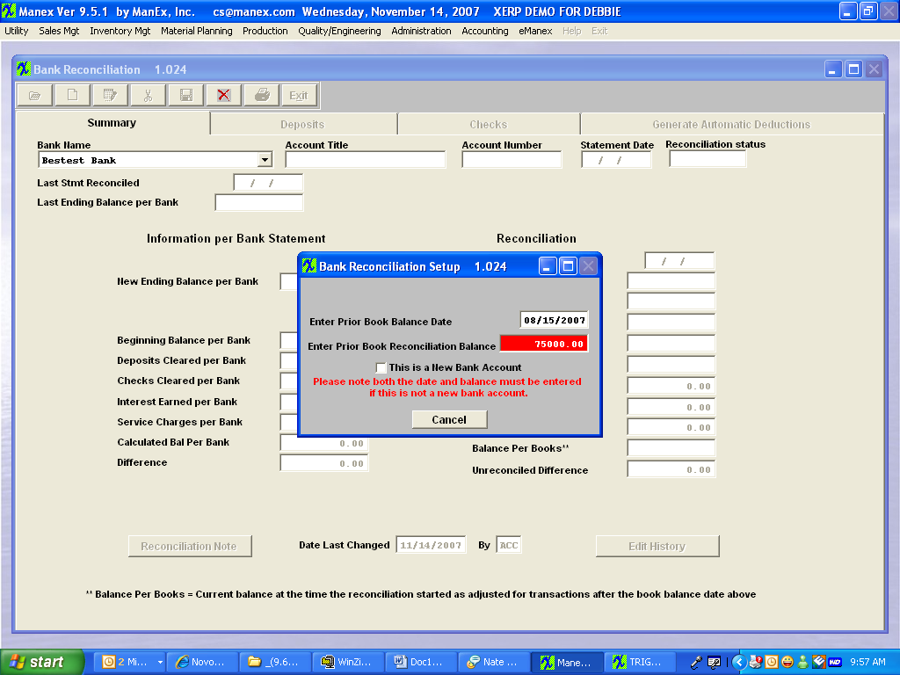
- Reconcile the first statement. 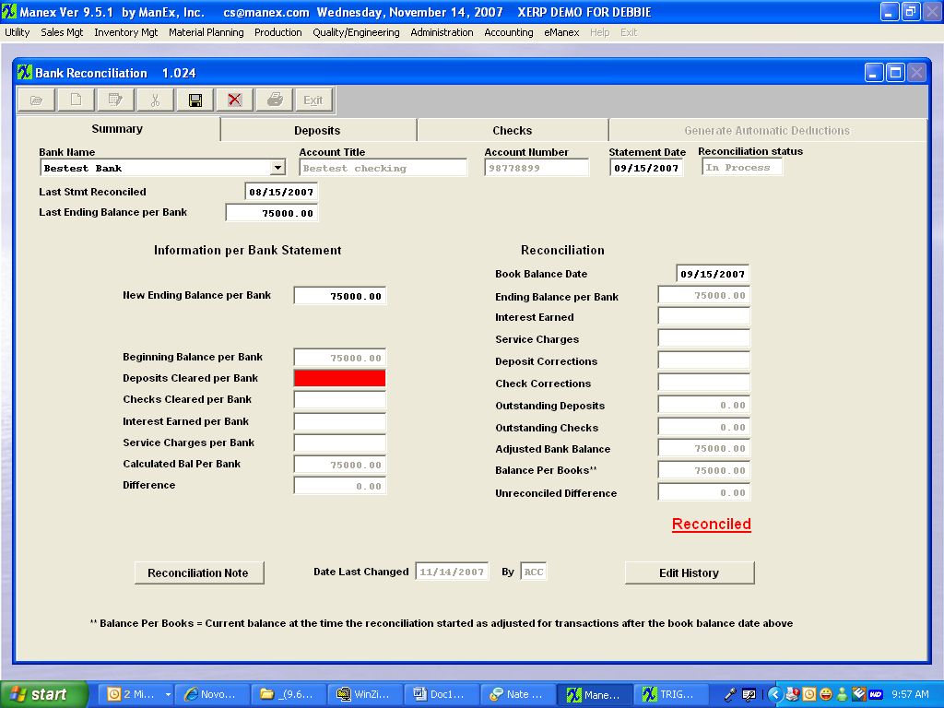
- Create a JE – notice that the Trans Date is 9/20/07. 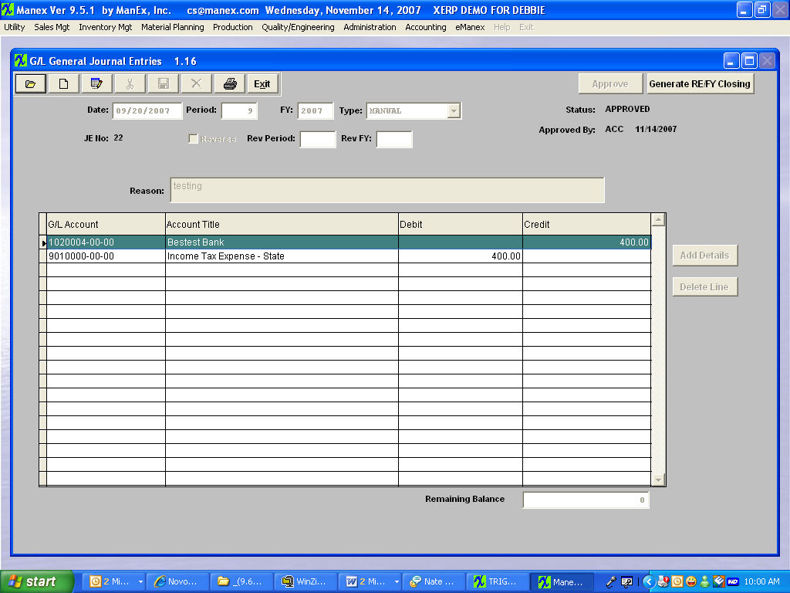
- Release to GL. 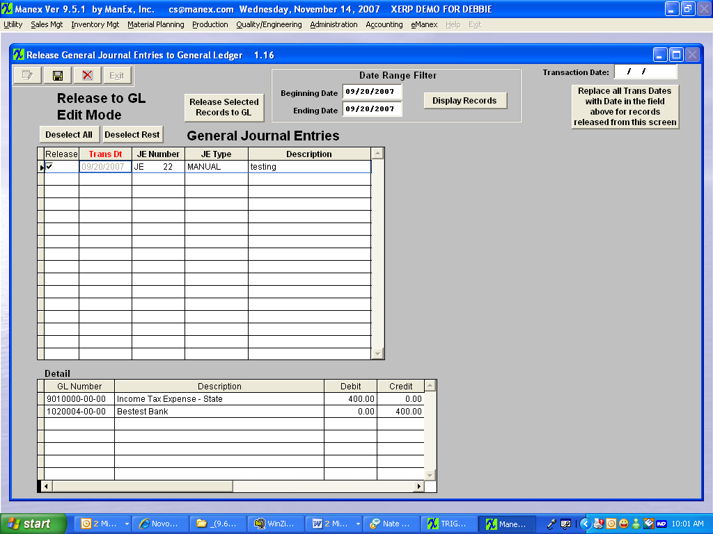
- Post to GL. Tranaction date is 9/20/07. 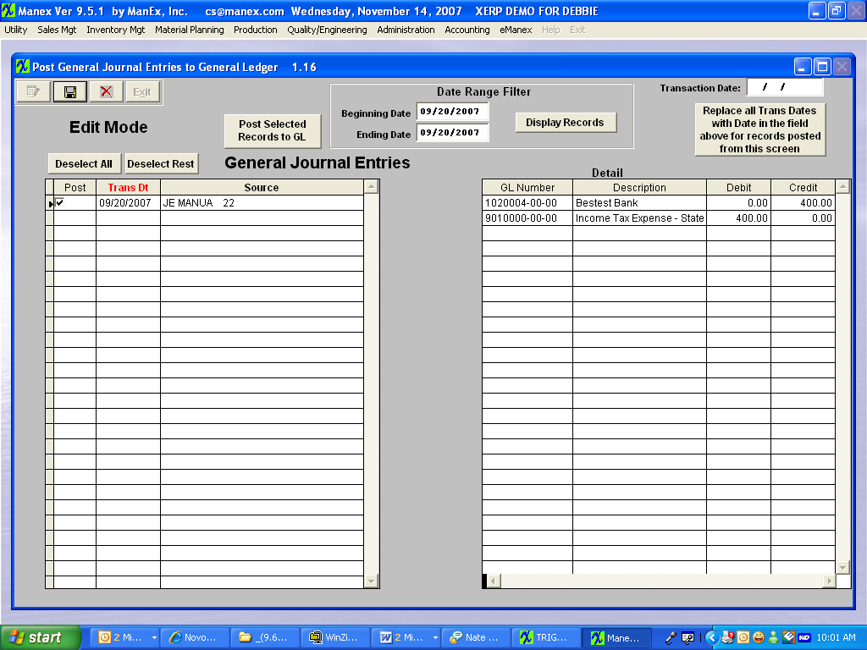
- But due to the fact that the code implemented will take the Post date not the Transaction date. The Bank Recon will go off of the 11/14/07 date that was saved in the tables. 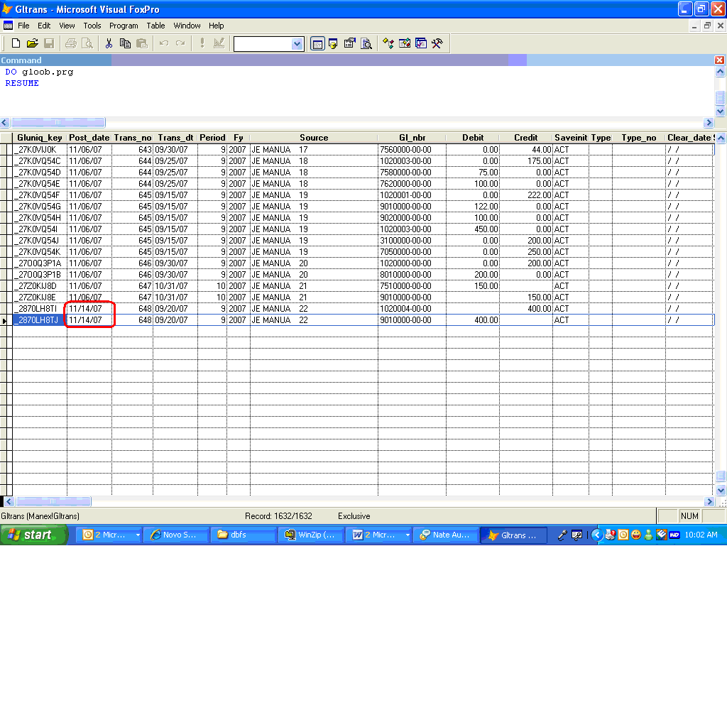
- Go to reconcile the statement for 10/15/07. It is correctly NOT including the JE because it is supposed to go off of the Post date, not the Transaction date. 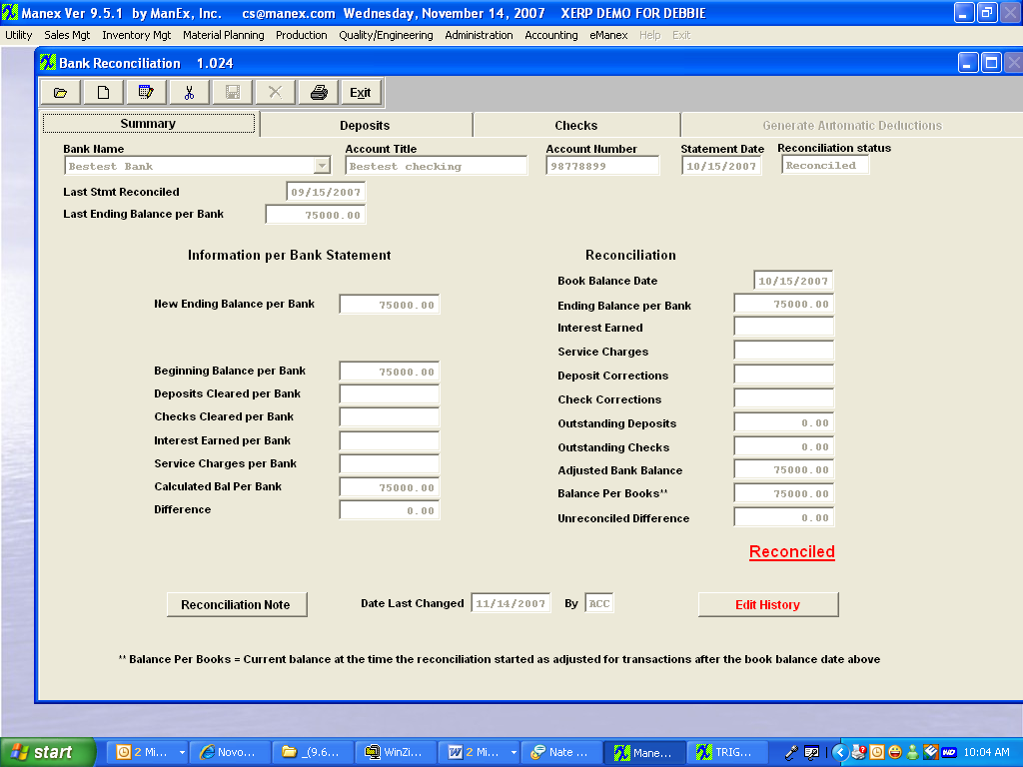
- The next statement that I process properly takes the JE into the Bank Balance per Book field based on the Post date. 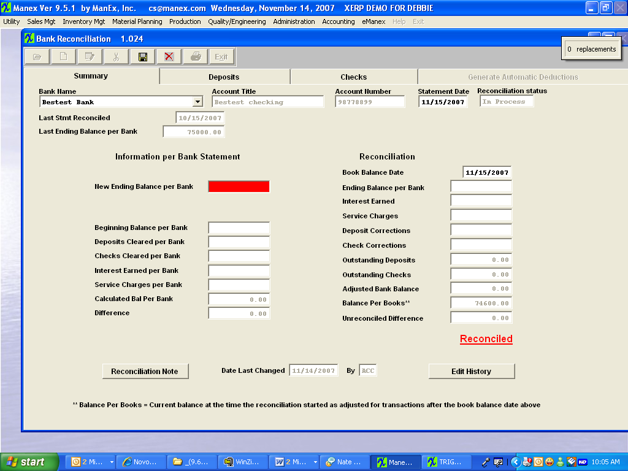
- I reconciled the statement. Note that the Information per Bank Statement column will have a difference of the 400.00. But that is due to the fact that the only time the users should create a JE against a bank account is if their records don’t match the Bank Statement in the first place and they can not figure out why and they just use the JE to correct the numbers. So it should not happen very often. 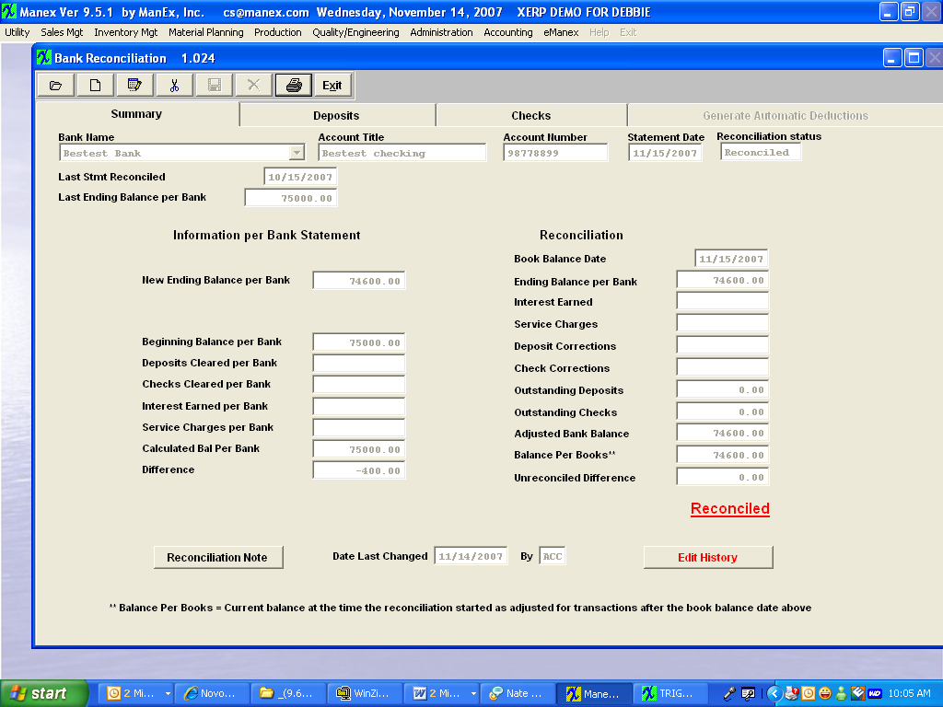
- The next statement comes out ok. 

