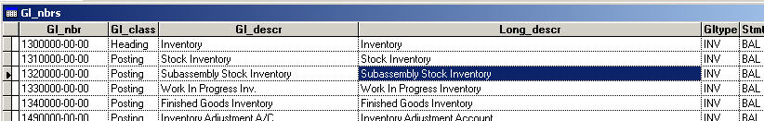
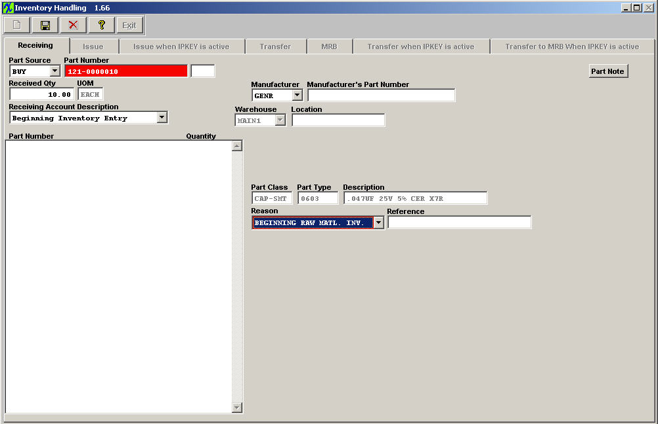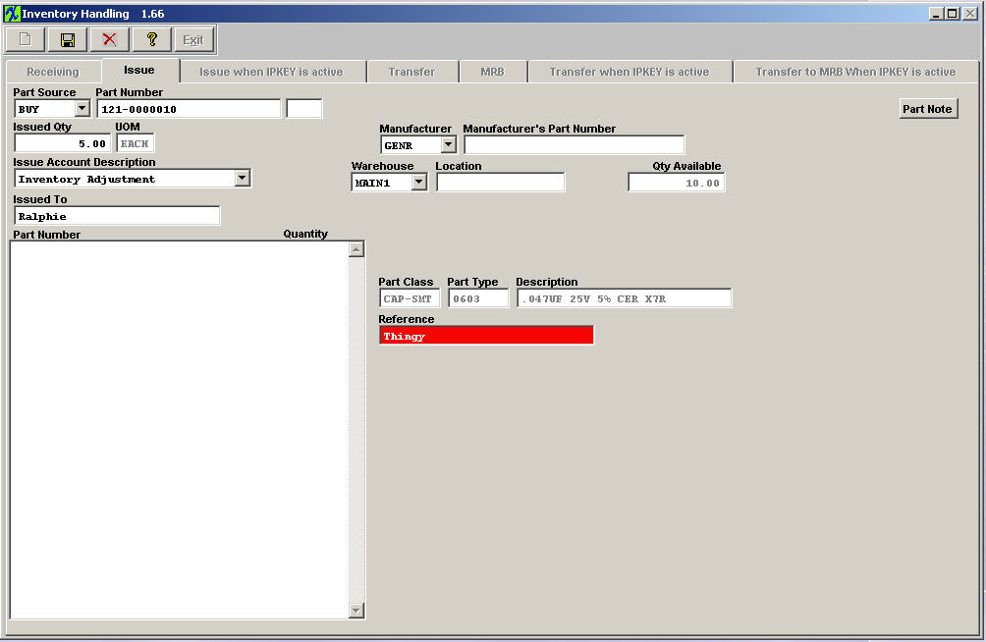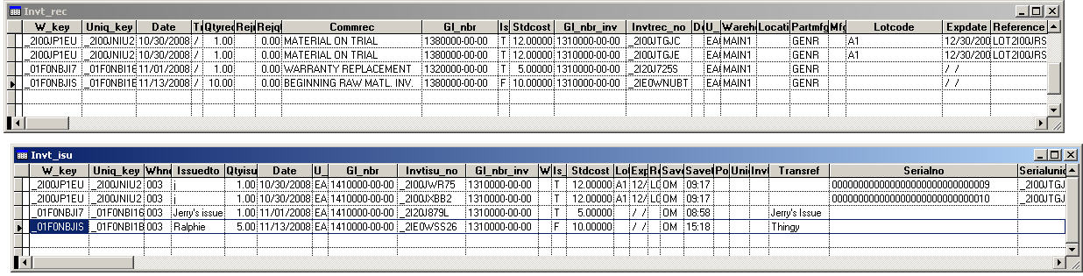On both the receiving and issuing transactions, the account descriptions are not carried into the transaction record. They are only used to identify the account used in the transaction.

