Step 1 Create top and sub assemblies

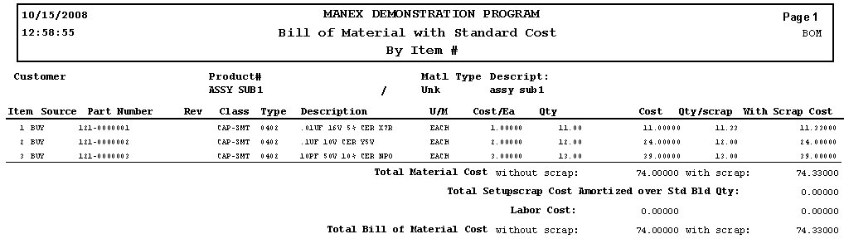
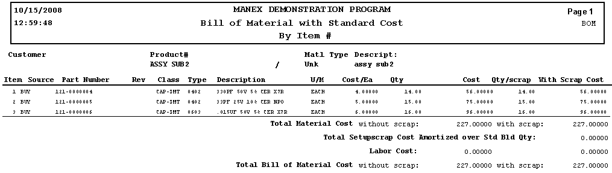
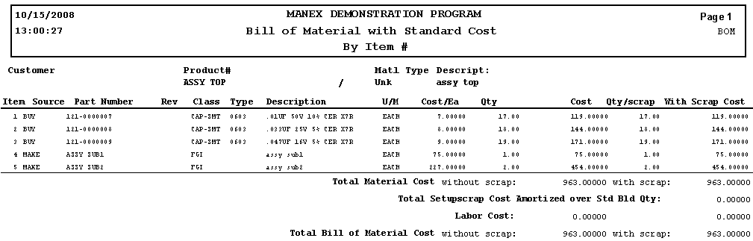

Step 2 Add standard cost to buy parts 121-0000001 through 0000010
(see cost/Ea in BOMs)

Step 3 Rolled up standard costs for assemblies
(no GL impact, no inventory)

Step 4 Bring in components to inventory
GL impact: use beginning inventory account)
View Trial Balance, Balance Sheet and Inventory & WIP values
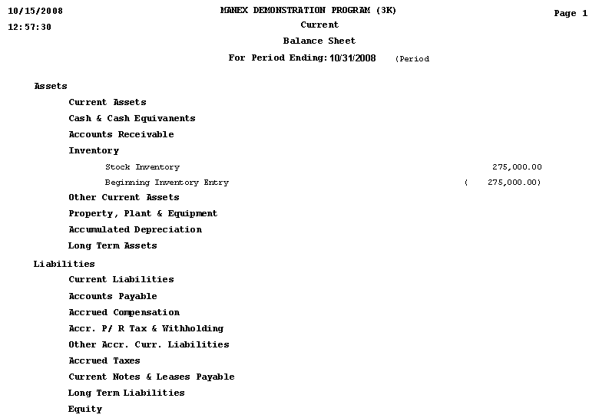
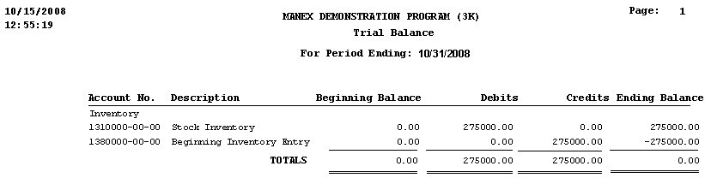

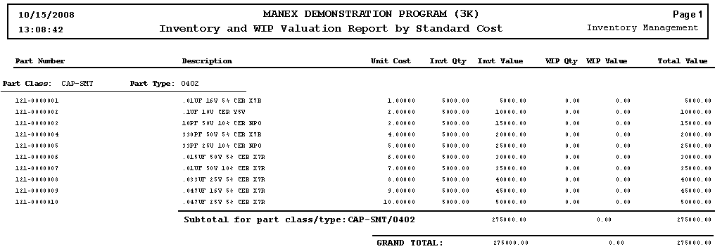

Step 5 Create work orders

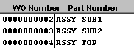
50 each
50 each
15 each

Step 6 Issue parts to sub work orders.
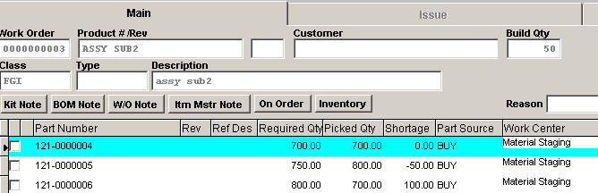
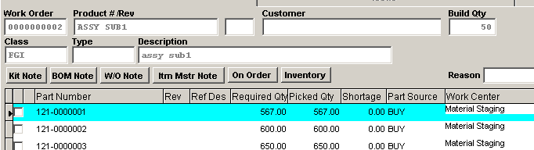

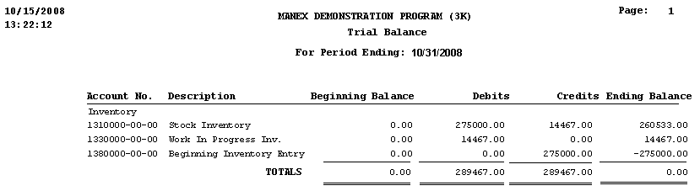

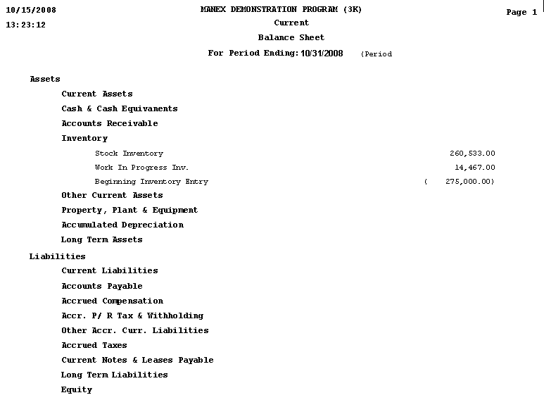

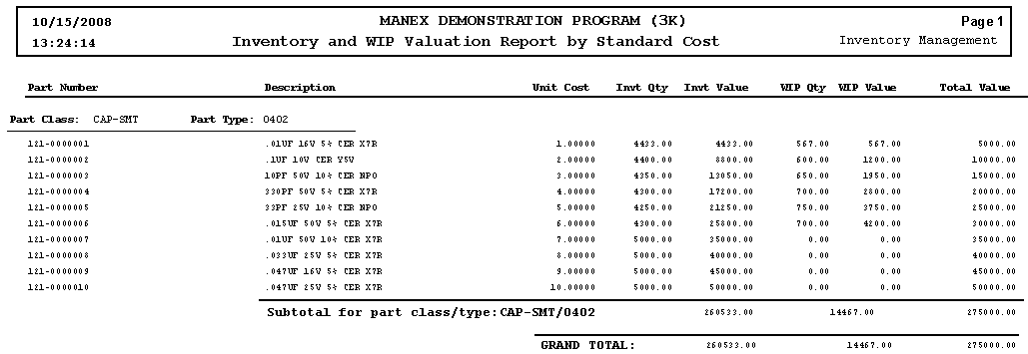

Step 7 Change cost std for part 121-0000004 (from $4 to $5.50)

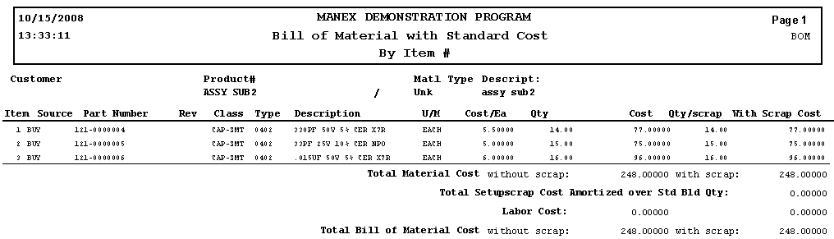
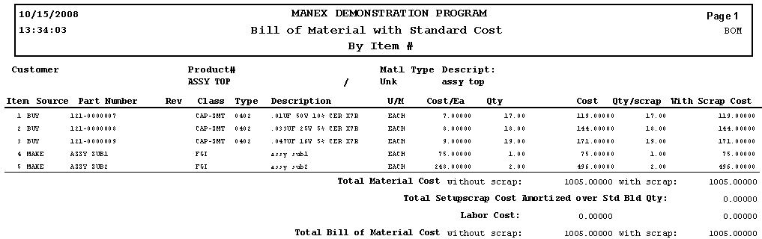

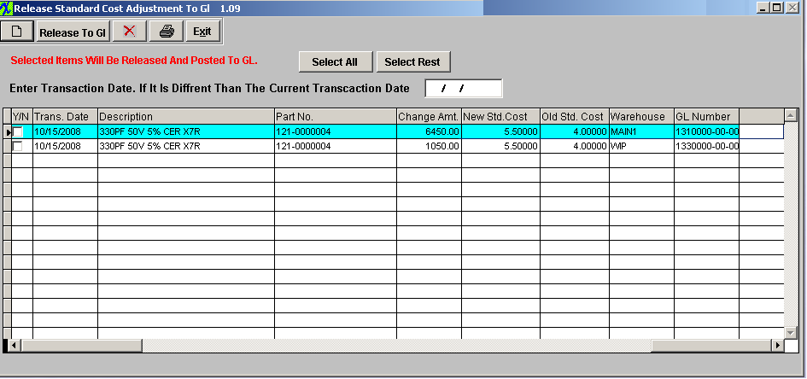
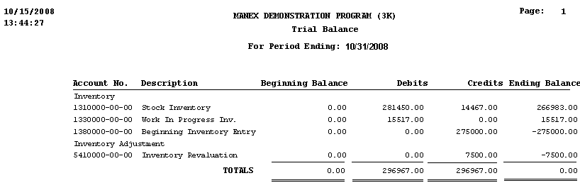
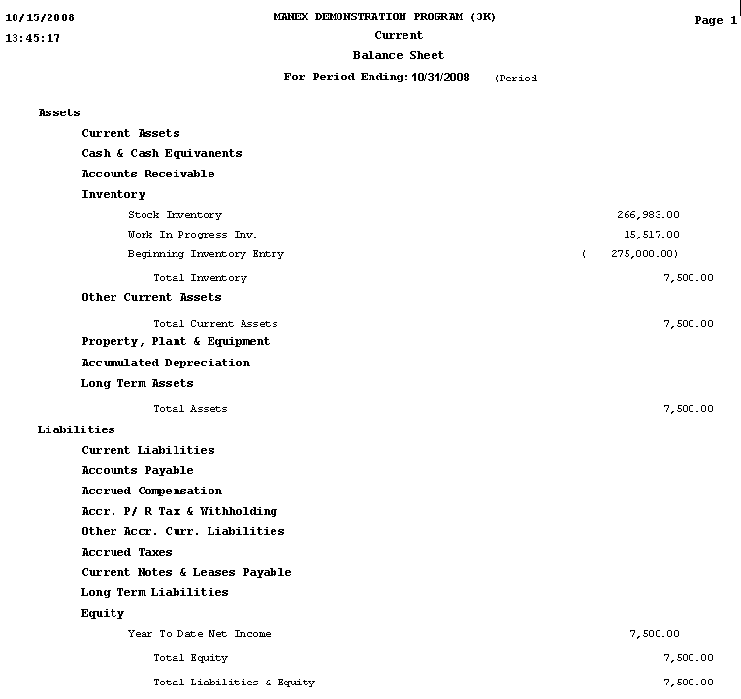

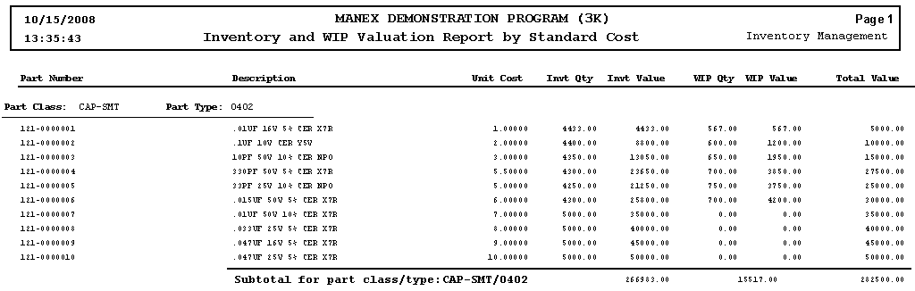

Step 8 Move subs to FGI
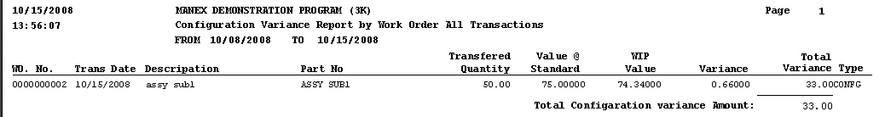

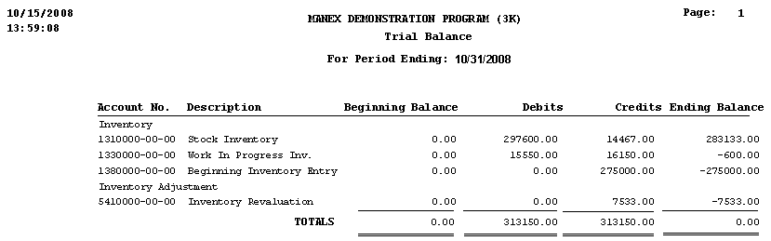
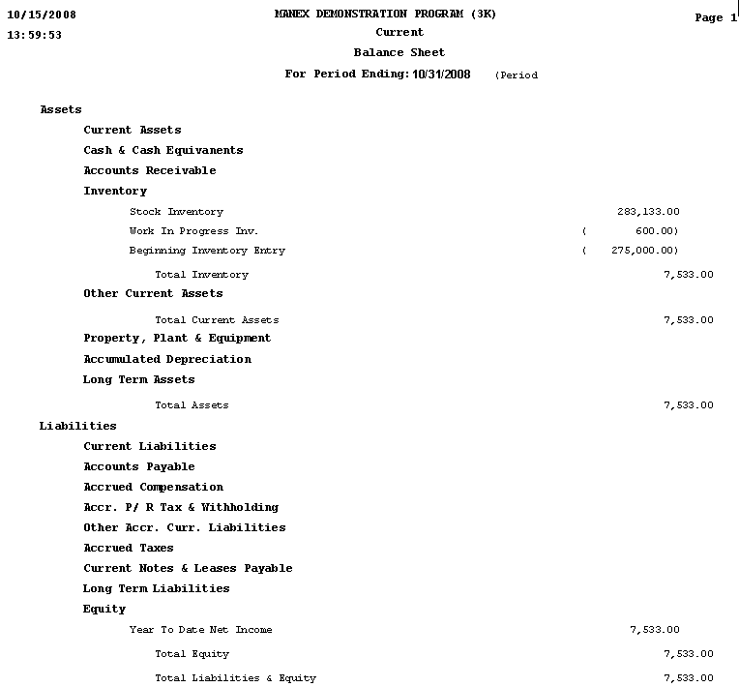
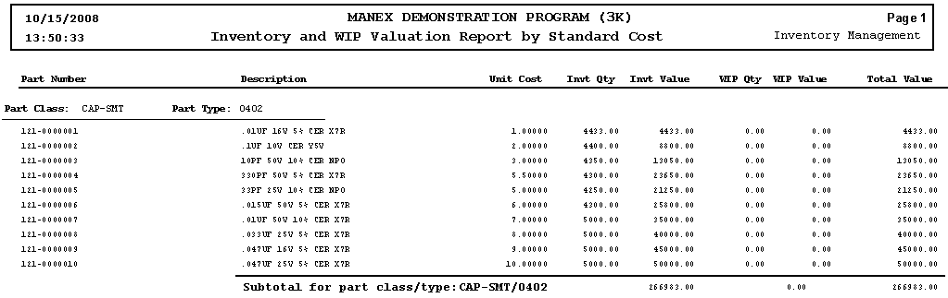
Step 9 Close the Kits

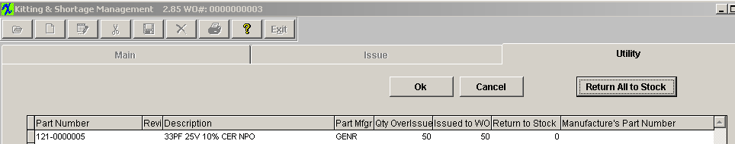
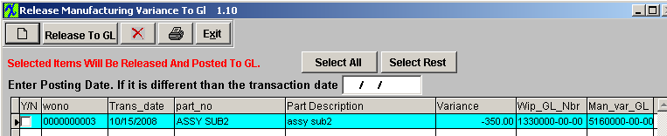
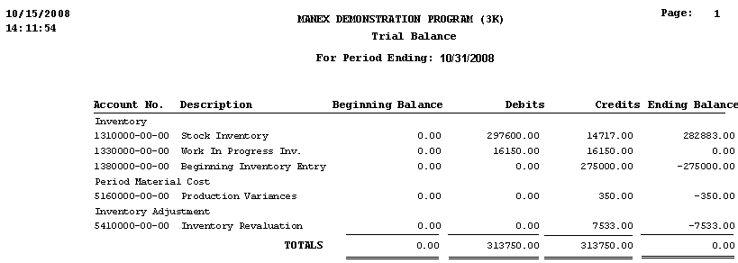

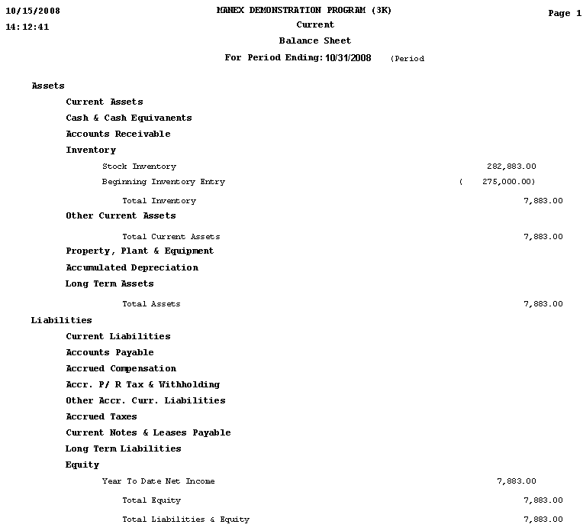

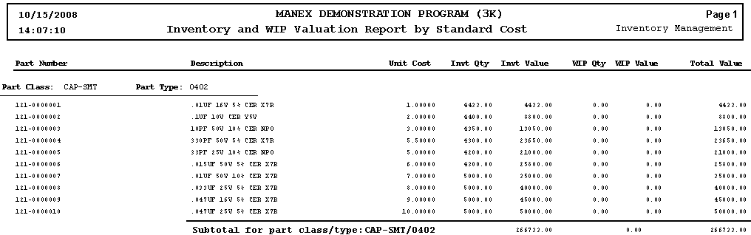
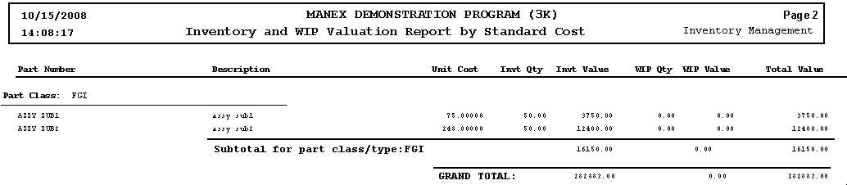

Step 10 Kit the top assembly

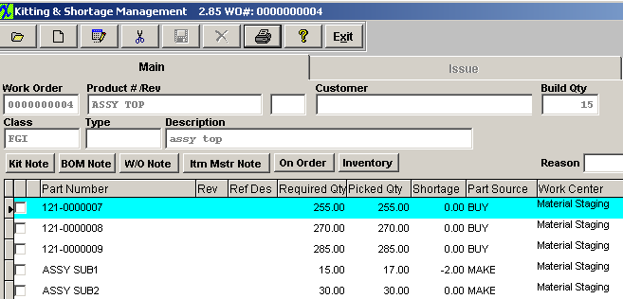

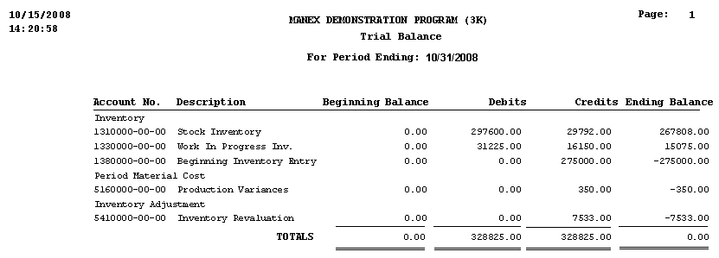
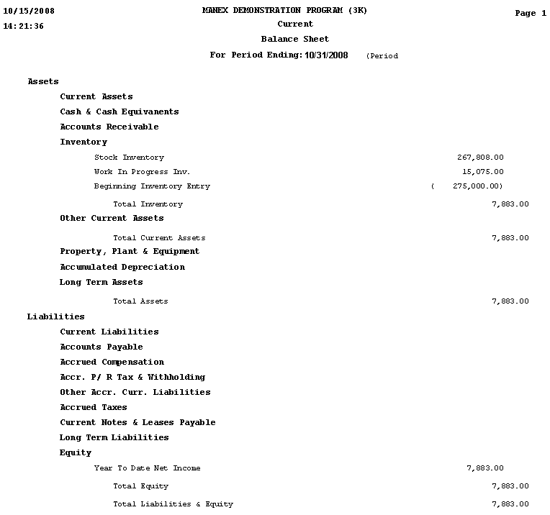

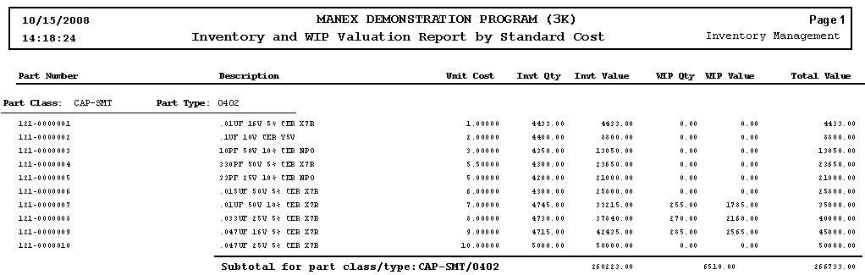
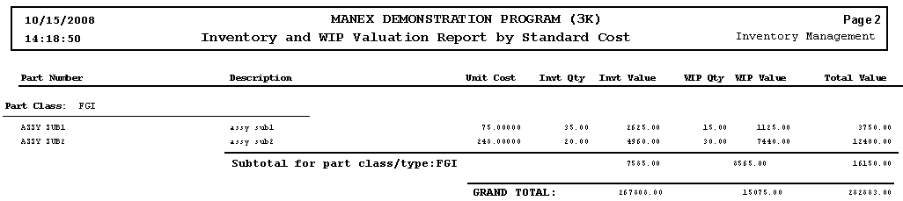

Step 11 Do another cost adjustment (121-0000009, from $9 to $8.25)
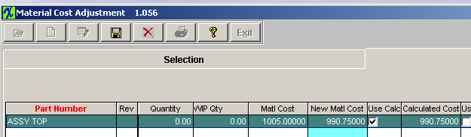

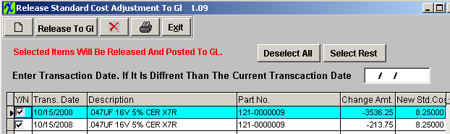

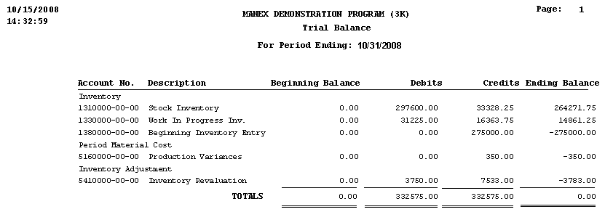

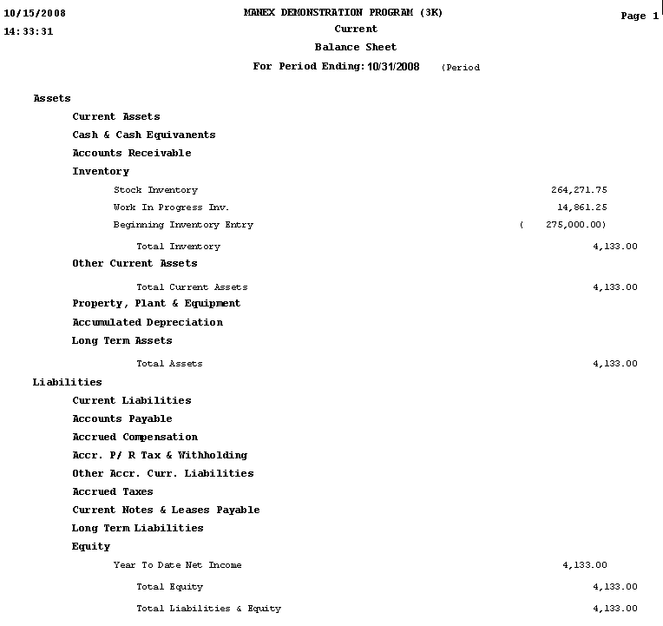

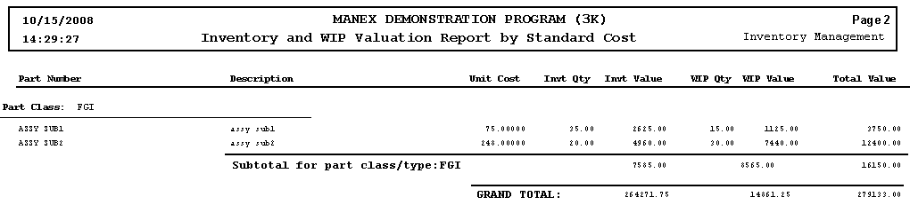
Step 12 Move assys to FGI

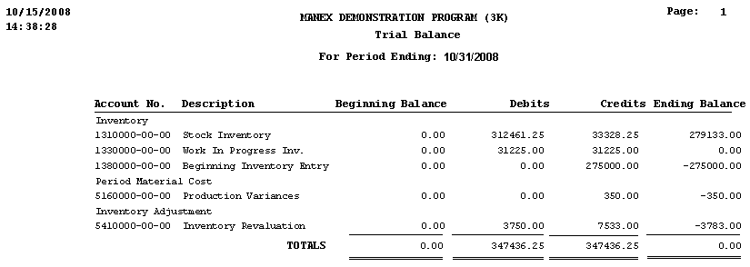

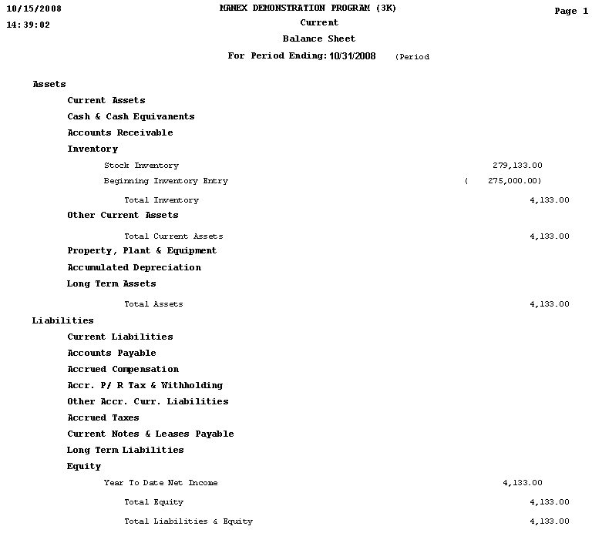

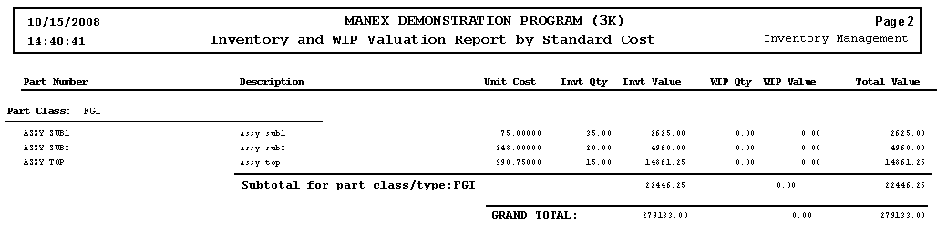
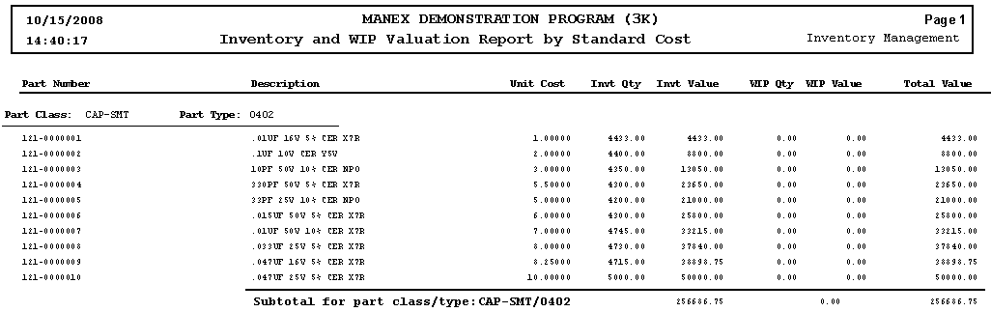

Step 13 Close Kit



